Ana ekran
İstifadəçi sistemə giriş etdikdən sonra
Ekranın yuxarı hissəsində
MASA SATIŞI
PAKET SATIŞI
TAKE AWAY
Lazımlı table - lər (
SELECT AutoID, EmployeeID, FirstName, LastName, SocialSecurityNumber, MailingAddress, MailingZipCode, SmarCardCode, MifareCardCode, DateHired, DateReleased, EmployeeActive, JobTitleID, SecurityLevel, AccessCode, TipsReceived, PayBasis, PayRate, ScanCode, DriverLicenseNumber, DriverLicenseExpires, CarInsurancePolicyCarrier, CarInsurancePolicyNumber, CarInsurancePolicyExpires, CarInsurancePolicyNotes, PrefUserInterfaceLocale, EmployeeNotes, OrderEntryUseSecLang, EmployeeIsDriver, DefaultOEMenuGroupID, UseStaffBank, ScheduleNotEnforced, UseHostess, IsAServer, IsOffline, NoCashierOut, EditTimestamp, PhoneNumber, RevenueCenterTypeID, DeleteReason, EditKey, SyncKey, BranchID, AddUserID, AddDateTime, EditUserID, EditDateTime, EmployeeKey, MonthlyDinnerFee, SendOK FROM EmployeeFiles

ÇAĞIR (Çekləri görə bildiyimiz hissə).
Table adı
SELECT AutoID, OrderID, ReceiptNo, MainOrderKey, MainOrderID, OrderTypeSourceID, OrderTypeSourceExternalNo, OrderKey, OrderDateTime, EmployeeID, StationID, RevenueCenterTypeID, OrderType, DineInTableID, CustomerID, DeliveryCharge, DeliveryComp, DeliveryZoneID, DriverEmployeeID, DriverDepartureTime, DriverArrivalTime, OnHoldUntilTime, SalesTaxRate, DiscountID, DiscountLineAmount, DiscountOrderAmount, DiscountCashAmount, DiscountTotalAmount, DiscountAmountValue, DiscountBasisValue, OrderStatus, BonusAmountUsed, BonusAmountEarned, BonusID, BonusCustomerID, AmountDue, PackagerAlreadyPrinted, GuestCheckPrinted, GuestCheckPrintCount, AdditionPrinted, AdditionPrintedLineCount, SurchargeID, SurchargeLineAmount, SurchargeOrderAmount, SurchargeCashAmount, SurchargeTotalAmount, ComplimentaryAmount, SubTotal, OrderCost, GratuityPercent, CashGratuity, SalesTaxAmount, DriveThruComplete, BarTabName, TableReady, GuestNumber, SpecificCustomerName, OrderPhone, InvoicePrinted, FiscalPrinted, OrderNotes, OrderExternalNotes, LineDeleted, DeleteReason, CustomField1, CustomField2, CustomField3, CustomField4, CustomField5, EditKey, SyncKey, BranchID, LockData, LockStationID, AddUserID, AddDateTime, EditUserID, EditDateTime, DayEnd, IsProduced, CustomerKey, DiscountKey, EmployeeKey, EmployeeName, DineInTableName, CustomerName, AddUserName, EditUserName, ExternalOrderStatus, FiscalKey, InvoiceDetail, SendOK, RetailData, FiscalStatus, DiscountUserName, ingenico, PaperNumber, PosVersion, ModuleVersion, InvoiceSendOK, IsInvoice, Inv_IsEarchive, Inv_IsEinvoice, Inv_SerialNo, Inv_CustomerName, Inv_TaxNo, Inv_TaxOffice, Inv_EMail, Inv_Phone, Inv_Address, Inv_Notes, Inv_ReferenceNo, Inv_IsDiplomatic, Inv_IsCustomAmount, Inv_CustomTaxName08, Inv_CustomTaxName18, Inv_CustomAmount08, Inv_CustomAmount18, CustomField6, CustomField7, CustomField8, CustomField9, CustomField10, IsKiosk, CustomerBalanceAmount, CustomerSpecialBonusPercent, CustomerBonusName, ReturnType, ReturnOrderNo, ReturnCustomerName, ReturnCustomerAddress, ReturnTaxNumber, ReturnTaxOffice, ReturnSerialNo, ReturnReason, ReturnReasonCode, UsdAmount, EurAmount, GbpAmount, OrderCounter, TsmStatus, FiscalGmpUniqueKey, Inv_Type, Inv_Urn, PromotionName, PromotionCashAmount, IsFrink, FrinkOrderNo, FrinkCustomerName, FrinkStatus, IsTekfenPersonal, TekfenActionKey, TekfenPersonalFullName, TekfenCardNumber, TekfenNotes, TekfenProcessType, TekfenCompanyName, WebOrderKey, RoundAmount, ManualProductionDate, IsCustomerAdvance, FiscalBoxResult, VoidSendOK, IsVigo, VigoStatus, VigoOrderId, VigoDeliveryId, VigoTimeline
FROM OrderHeaders WHERE (OrderID = 5296)

aşağı hissədə
KASSA GİRİŞİ
KASSA ÇIXIŞI
Table adı
(SELECT RegisterSessionID, BranchID, EmployeeID, RegisterSessionKey, StationID, AccountingDateTime, SignInDateTime, RegisterStartAmount, SignOutDateTime, RegisterEndAmount, DiscrepancyAmount, DiscrepancyNotes, ManagerEmployeeID, TotalPaymentMethod1, TotalPaymentMethod2, TotalPaymentMethod3, TotalPaymentMethod4, TotalPaymentMethod5, TotalPaymentMethod6, TotalPaymentMethod7, TotalPaymentMethod8, TotalPaymentMethod9,TotalPaymentMethod10, TotalPaymentMethod11, TotalPaymentMethod12, TotalPaymentMethod13, TotalPaymentMethod14, TotalPaymentMethod15, TotalPaymentMethod16, TotalPaymentMethod17, TotalPaymentMethod18, TotalPaymentMethod19, TotalPaymentMethod20, ClosePaymentMethod1, ClosePaymentMethod2, ClosePaymentMethod3, ClosePaymentMethod4, ClosePaymentMethod5, ClosePaymentMethod6, ClosePaymentMethod7, ClosePaymentMethod8, ClosePaymentMethod9, ClosePaymentMethod10, ClosePaymentMethod11, ClosePaymentMethod12, ClosePaymentMethod13, ClosePaymentMethod14, ClosePaymentMethod15, ClosePaymentMethod16, ClosePaymentMethod17, ClosePaymentMethod18, ClosePaymentMethod19, ClosePaymentMethod20, ZReportID, EditKey, SyncKey, DiscrepancyNotes2, EmployeeKey, PaymentMethodName1, PaymentMethodName2, PaymentMethodName3, PaymentMethodName4, PaymentMethodName5, PaymentMethodName6, PaymentMethodName7, PaymentMethodName8, PaymentMethodName9, PaymentMethodName10, PaymentMethodName11, PaymentMethodName12, PaymentMethodName13, PaymentMethodName14,PaymentMethodName15, PaymentMethodName16, PaymentMethodName17, PaymentMethodName18,PaymentMethodName19,PaymentMethodName20, SendOK, TotalPaymentMethod21,TotalPaymentMethod22,TotalPaymentMethod23, TotalPaymentMethod24, TotalPaymentMethod25, TotalPaymentMethod26, TotalPaymentMethod27, TotalPaymentMethod28, TotalPaymentMethod29, TotalPaymentMethod30, TotalPaymentMethod31, TotalPaymentMethod32, TotalPaymentMethod33, TotalPaymentMethod34, TotalPaymentMethod35, TotalPaymentMethod36, TotalPaymentMethod37, TotalPaymentMethod38, TotalPaymentMethod39, TotalPaymentMethod40, ClosePaymentMethod21, ClosePaymentMethod22, ClosePaymentMethod23, ClosePaymentMethod24, ClosePaymentMethod25, ClosePaymentMethod26, ClosePaymentMethod27, ClosePaymentMethod28, ClosePaymentMethod29, ClosePaymentMethod30, ClosePaymentMethod31, ClosePaymentMethod32, ClosePaymentMethod33, ClosePaymentMethod34, ClosePaymentMethod35, ClosePaymentMethod36, ClosePaymentMethod37, ClosePaymentMethod38, ClosePaymentMethod39, ClosePaymentMethod40, PaymentMethodName21, PaymentMethodName22, PaymentMethodName23, PaymentMethodName24, PaymentMethodName25, PaymentMethodName26, PaymentMethodName27, PaymentMethodName28, PaymentMethodName29, PaymentMethodName30, PaymentMethodName31, PaymentMethodName32, PaymentMethodName33, PaymentMethodName34, PaymentMethodName35, PaymentMethodName36, PaymentMethodName37, PaymentMethodName38, PaymentMethodName39, PaymentMethodName40, FiscalBoxAccessToken
FROM RegisterSessions
WHERE (EmployeeID = 106))
ƏMƏLİYYATLAR
BACK OFFICE
ÇIXIŞ OLSUN.
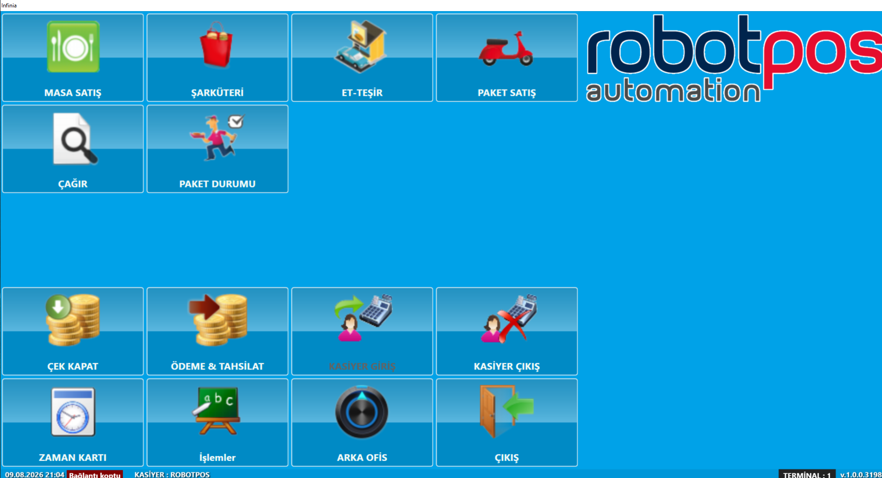

Masa satış ekranı
MASA SATIŞ Dediyimizdə sağ tərəfdə masa qrupları, sol tərəfdə masalar görünəcək.
Table adı (
SELECT AutoID, TableGroupID, TableGroupText, RevenueCenterTypeID, DeleteReason, CustomField1, CustomField2, CustomField3, CustomField4, CustomField5, EditKey, SyncKey, BranchID, AddUserID, AddDateTime, EditUserID, EditDateTime, TableGroupKey, TableRowCount, TableColumnCount, SendOK
FROM DineInTableGroups
SELECT AutoID, DineInTableID, DineInTableText, SectionNumber, TableGroupID, DisplayIndex, DineInTableActive, MaxGuests, Smoking, Window, Booth, Privacy, PictureName, AvarageSeatTime, RevenueCenterTypeID, SecurityLevel, DeleteReason, CustomField1, CustomField2, CustomField3, CustomField4, CustomField5, EditKey, SyncKey, BranchID, AddUserID, AddDateTime, EditUserID, EditDateTime, DineInTableKey, TableGroupKey, SendOK FROM DineInTables WHERE (DineInTableID = 1)
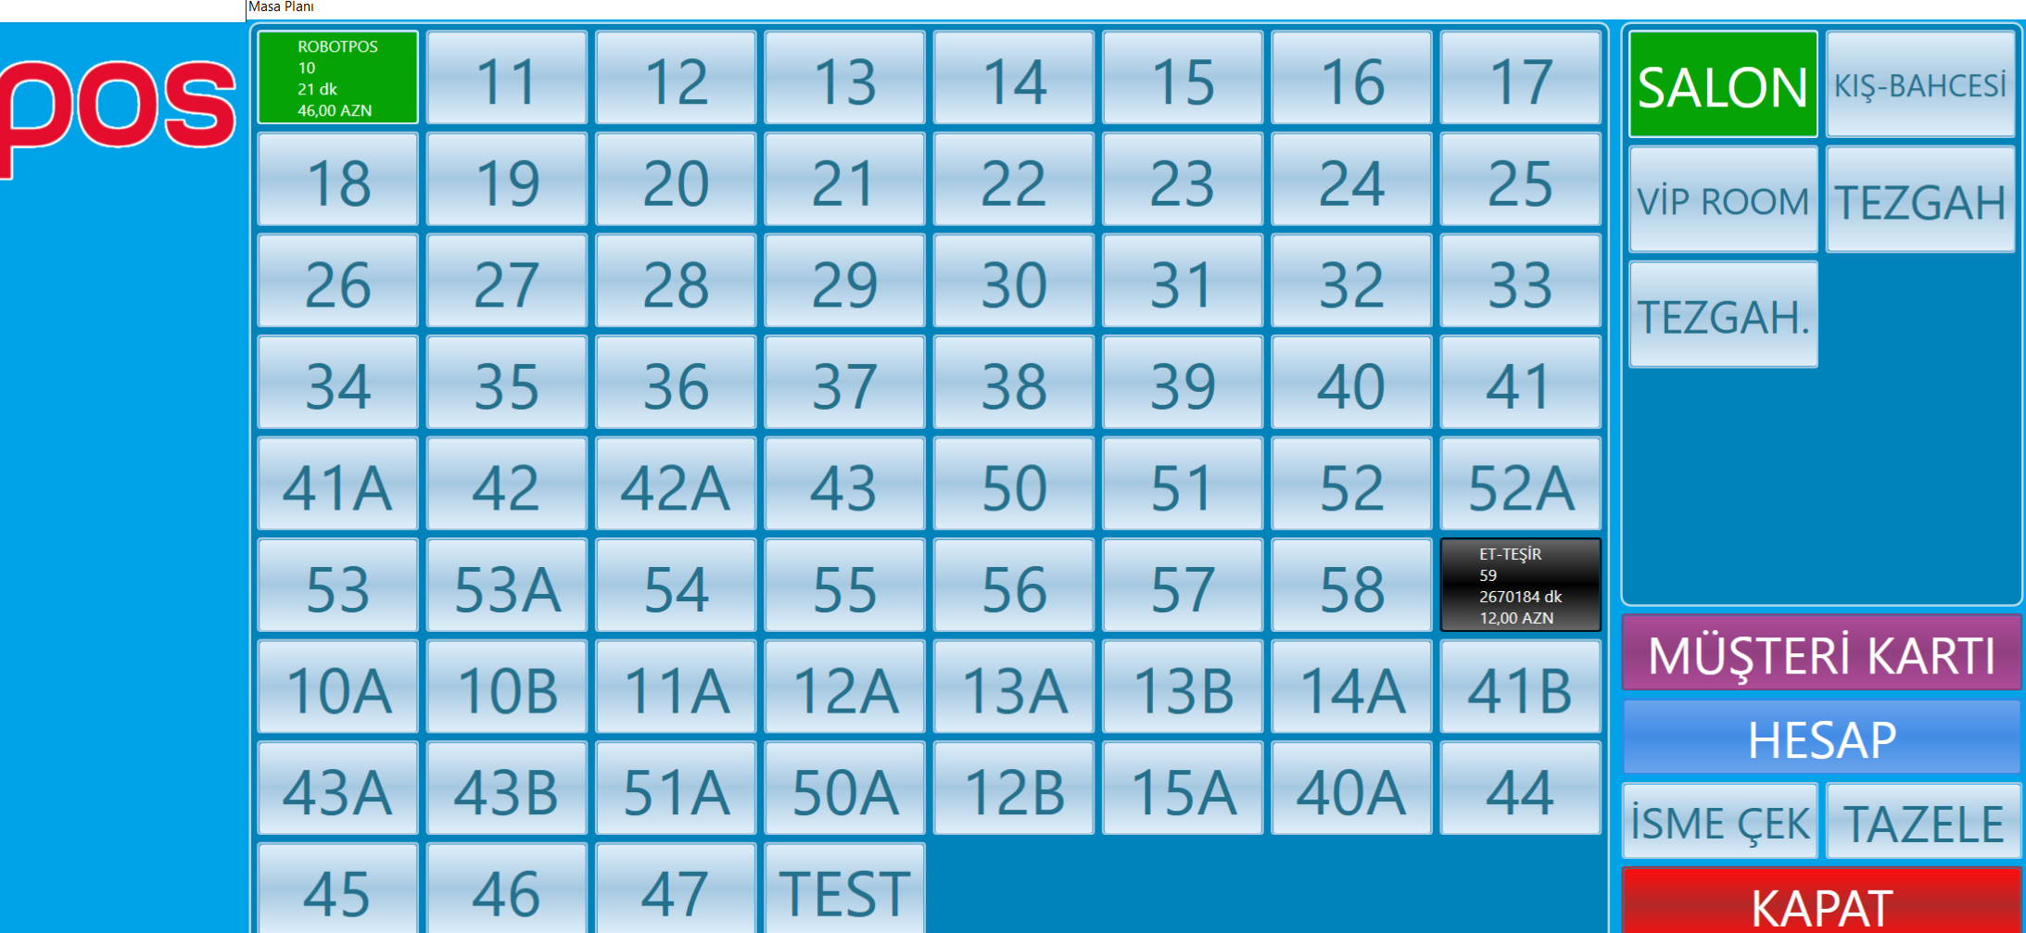
SATIŞ EKRANI (Masaya Daxil Olduqda).
Table (
SELECT AutoID, MenuItemID, MainMenuItemID, RevenueCenterTypeID, MenuItemText, MenuCategoryID, MenuGroupID, TaxGroupID, DisplayIndex, DefaultUnitPrice, MenuItemCost, MenuItemDescription, MenuItemNotification, MenuItemActive, MenuItemInStock, MenuItemTaxable, TaxPercent, MenuModifierID, MenuItemDiscountable, MenuItemPopUpHeaderID, MenuItemPopUpChoiceText, HasModifierPopUps, SecLangMenuItemText, SecLangPopUpChoiceText, PictureName, ShowCaption, IsComboMenu, IsTopMenu, ButtonColor, Barcode, Barcode2, ItemDelCharge, ItemDelComp, DineInPrice, BarTabPrice, TakeOutPrice, DriveThruPrice, DeliveryPrice, OrderByWeight, PrintPizzaLabel, KitchenSortNumber, ModBuilderTemplateID, MenuItemTypeID, AccountingCode, UsedPrinterID1, UsedPrinterID2, UsedPrinterID3, UsedPrinterID4, UsedPrinterID5, UseKds1, UseKds2, UseKds3, UseKds4, UseKds5, UseKds6, UseKds7, UseKds8, UseKds9, UseKds10, MainMenuItemKey, MenuCategoryKey, MenuGroupKey, MenuItemGlobalKey, MenuItemKey, MenuModifierForcedKey, MenuModifierForcedID, MenuModifierKey, TaxGroupKey, SaleStartDate, SaleEndDate, SecurityLevel, DeleteReason, CustomField1, CustomField2, CustomField3, CustomField4, CustomField5, EditKey, SyncKey, BranchID, AddUserID, AddDateTime, EditUserID, EditDateTime, CountDownDate, CountDownValue, CountDownActualResult, PrintOnLabel, SendOK, MaxSaleQuantity, Barcode3, Barcode4, Barcode5, Barcode6, Barcode7, Barcode8, Barcode9, Barcode10, CustomField6, CustomField7, CustomField8, CustomField9, CustomField10, CustomField11, CustomField12, CustomField13, CustomField14, CustomField15, CustomField16, EcommerceCode FROM MenuItems
SELECT AutoID, MenuGroupID, MainMenuItemID, MenuItemID, DisplayIndex, BranchID, LayoutKey, MenuItemKey, EditKey, SyncKey, MainMenuItemKey, MenuGroupKey FROM MenuItemLayout
SELECT MenuCategoryID, MenuCategoryKey, MenuCategoryText, MenuCategoryActive, DefaultTaxPercent, RevenueCenterTypeID, DeleteReason, CustomField1, CustomField2, CustomField3, CustomField4, CustomField5, EditKey, SyncKey, BranchID, AddUserID, AddDateTime, EditUserID, EditDateTime FROM MenuCategories
SELECT MenuGroupID, MenuGroupText, DisplayIndex, MenuGroupActive, SecLangMenuGroupText, PictureName, ShowCaption, HideInDineIn, HideInBar, HideInTakeaway, HideInCounter, HideInDelivery, ButtonColor, RevenueCenterTypeID, DeleteReason, CustomField1, CustomField2, CustomField3, CustomField4, CustomField5, EditKey, SyncKey, BranchID, AddUserID, AddDateTime, EditUserID, EditDateTime, MenuGroupKey FROM MenuGroups
SELECT MenuSubCategoryID, MenuSubCategoryKey, MenuSubCategoryText, MenuSubCategoryActive, DefaultTaxPercent, RevenueCenterTypeID, DeleteReason, CustomField1, CustomField2, CustomField3, CustomField4, CustomField5, EditKey, SyncKey, BranchID, AddUserID, AddDateTime, EditUserID, EditDateTime FROM MenuSubCategories)
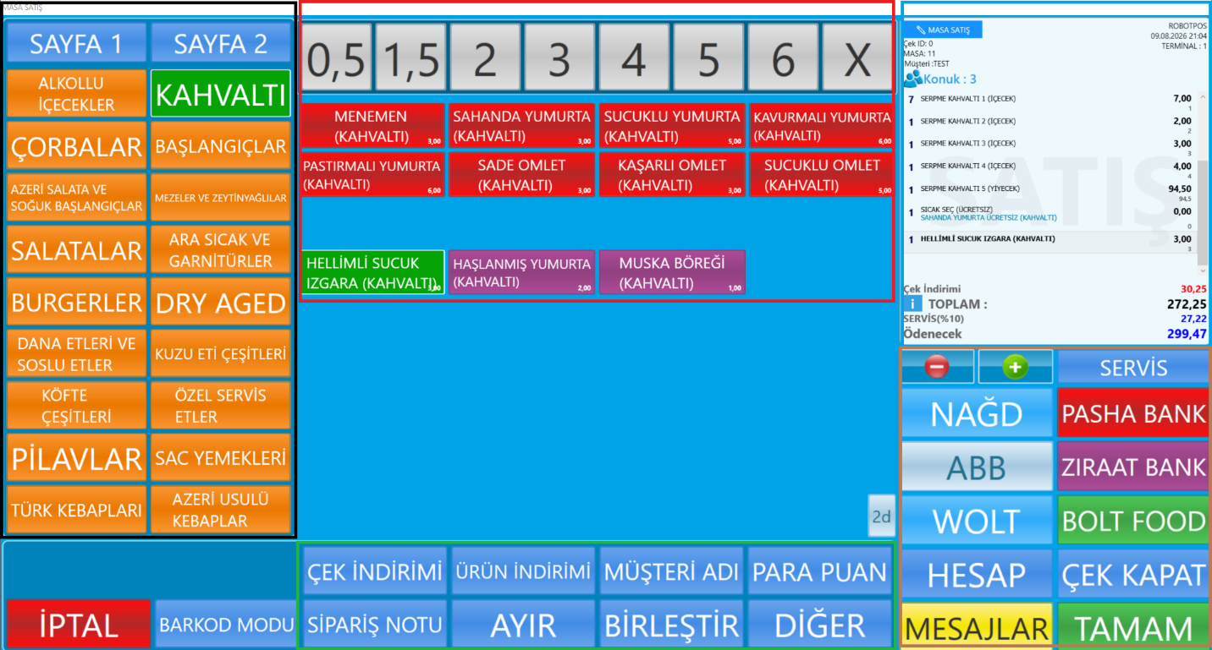

Bu ekranda rəngli çərçivələrlə ekranları izah edirəm.
Hər hansı masaya girdikdə sol tərəfdə
menu grupları (Qara hissə), mərkəz hissədə menu kateqoriyaları (qırmızı hissı) olur onları klik etdikdə issə menu açılır. Menular birbaşa qrupun içində də ola bilər.
Sağ yuxarı hissədə (göy hissə) SATIŞ Haqqında məlumatları özündə saxlayan panel yerləşir.
Satış növü istifadəçi tarix hansı terminal olduğu göstərilir, Çek id, Masa, Qonaq sayı.
SATIŞ PANELİNİN ALTINDA (Qəhvəyi hissə) Əlavə edilən satış əhsulunu artırb-azaltma, yanında Servis (cashgratituty) ondan altda ödəmə tipləri var.
Onun da altında HESAB (Müştəri hesabı, mesajlar (Modifikasiya), TAMAM Düyməsi var.
Yaşıl çərçivə ilə qeyd edilən hissədə isə hansı ki, mərkəz alt hissədə Çük üzərində əməliyyatlar var.
ÇEK İNDİRİMİ
SELECT DiscountID, DiscountKey, DiscountText, DiscountDescription, DiscountedAmountTaxable, DiscountExpireDate, DiscountActive, DiscountAmount, DiscountBasis, DiscountAllowedMinTicket, Barcode, DiscountMenuItemID, ButtonColor, PictureName, SecurityLevel, DeleteReason, CustomField1, CustomField2, CustomField3, CustomField4, CustomField5, EditKey, SyncKey, BranchID, AddUserID, AddDateTime, EditUserID, EditDateTime, UseGroupFilter, GroupMinimumQuantity, UseMenuItemFilter, MenuItemMinimumQuantity, UseOrderTotalFilter, OrderTotalMinimum, UseHourFilter, HourStart, HourEnd, UseDayFilter, DayList, DiscountStartDate, SkipMenuDiscountStatus, OrderTotalMaximum, DisablePromotion, SendOK, SecurityCode FROM Discounts
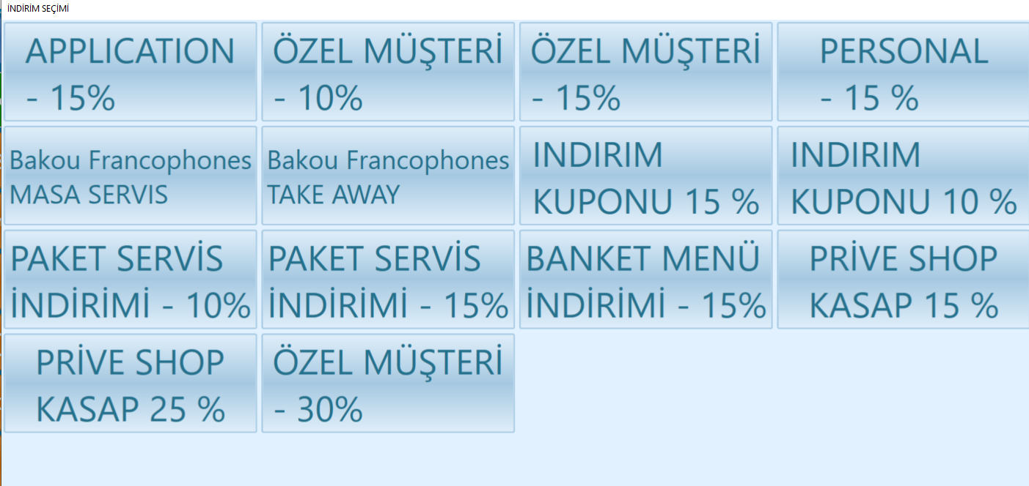
ÜRÜN ENDİRİM (Eynidir sadəcə məhsula endirim edir.
MÜŞTERİ ADI – Çeki müştəriyə tanıdırıq.
Table (
SELECT AutoID, CustomerID, CustomerKey, CustomerGlobalKey, CustomerIsActive, CustomerName, CustomerFullName, CardNumber, CustomerNotes, OrderCount, LastCallDate, CallingCount, AllowHouseAccount, IsFrequentDiner, CreditLimit, CreditSatusID, DiscountPercent, SpecialBonusPercent, TotalDebt, TotalPayment, TotalRemainig, BonusStartupValue, TotalBonusUsed, TotalBonusEarned, TotalBonusRemaing, CityName, District, Neighborhood, Avenue, Street, Buildings, Block, Apartment, ApartmentNo, FlatNo, IsDefault, TaxOfficeName, TaxNumber, ZipCode, AddressNotes, AreaCode, CustomerSpecialNotes, BirthDay, MaritialStatus, Age, EmailAddress, Sexuality, FacebookAccount, TwitterAccount, WebSite, PhotoPath, ProximityCardID, EditKey, SyncKey, BranchID, LockData, LockStationID, AddUserID, AddDateTime, EditUserID, EditDateTime, OpenValue, WebUserName, WebPassword, IsEmployee, DetailData, AparmentFlatNo, SendOK FROM CustomerFiles WHERE (CustomerID = 3) )
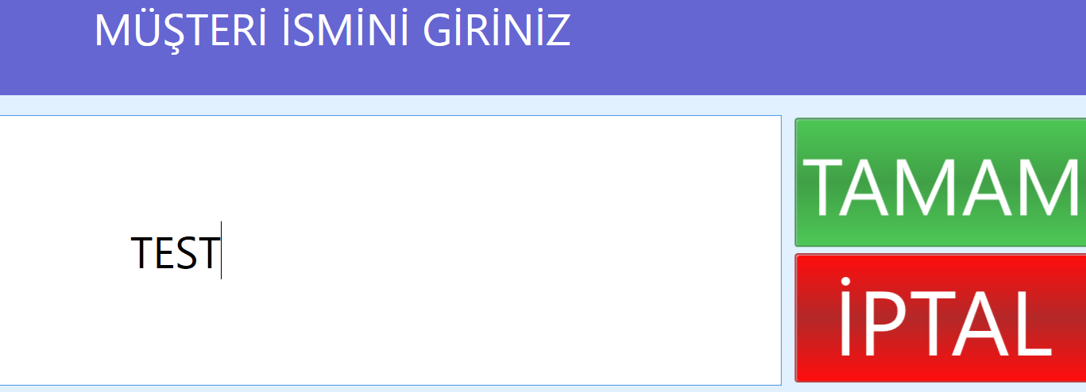
PARA PUAN
Daxil olduqda bu pəncərə açılır. Müştəriyə təyin olunan xalları burdan istifadə edərək ödənişi həyata keçirir.
Table: SELECT AutoID, CustomerID, CustomerKey, CustomerGlobalKey, CustomerIsActive, CustomerName, CustomerFullName, CardNumber, PhoneNumber, CustomerNotes, OrderCount, LastCallDate, CallingCount, AllowHouseAccount,IsFrequentDiner, CreditLimit, CreditSatusID, DiscountPercent, SpecialBonusPercent, TotalDebt, TotalPayment, TotalRemainig, BonusStartupValue, TotalBonusUsed, TotalBonusEarned, TotalBonusRemaing, CityName, District, eighborhood, Avenue, Street, Buildings, Block, Apartment, ApartmentNo, FlatNo, IsDefault, TaxOfficeName, TaxNumber, ZipCode, AddressNotes, AreaCode, CustomerSpecialNotes, BirthDay, MaritialStatus, Age, EmailAddress, Sexuality, FacebookAccount, TwitterAccount, WebSite, PhotoPath, ProximityCardID, EditKey, SyncKey, BranchID, LockData, LockStationID, AddUserID, AddDateTime, EditUserID, EditDateTime, WebUserName, WebPassword, OpenValue, DayCount, ailyAmount, CustomerCode, LastAddedCreditID, SendOK FROM BonusCustomerFiles WHERE CustomerID = 3
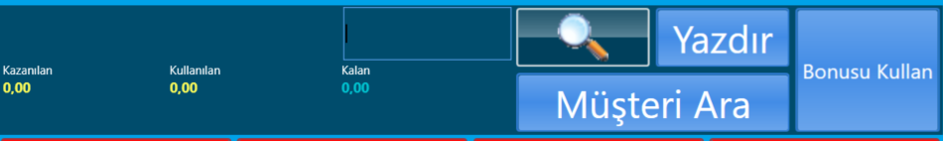
SİPARİŞ NOTU – Sifarişə not YazırsıZ.
ÜRÜN AYIR – Məhsulu çeklərə bölmək başqa çekə atmaq və sairə.
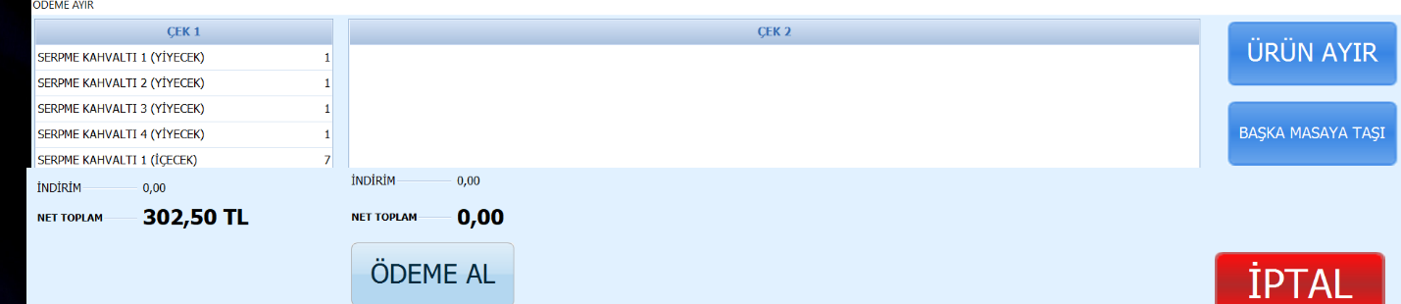
BİRLEŞTİR – Hal-hazırdakı çekimizi siyahıda olan çeklə birləşdiririk.
Table: OrderHeaders, OrderTransactions Cədvəlləri.
DİGƏR-Hissədə bu funksionallıqlar yerləşir.
Table: OrderHeaders, OrderTransactions Cədvəlləri
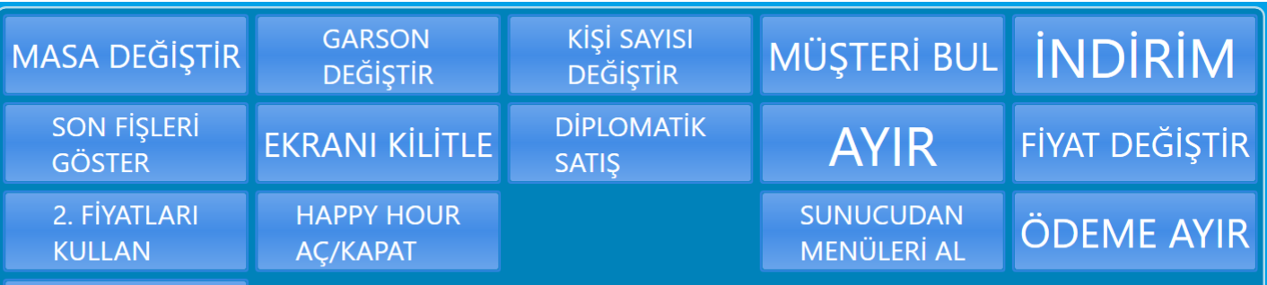
NAĞD – Basanda
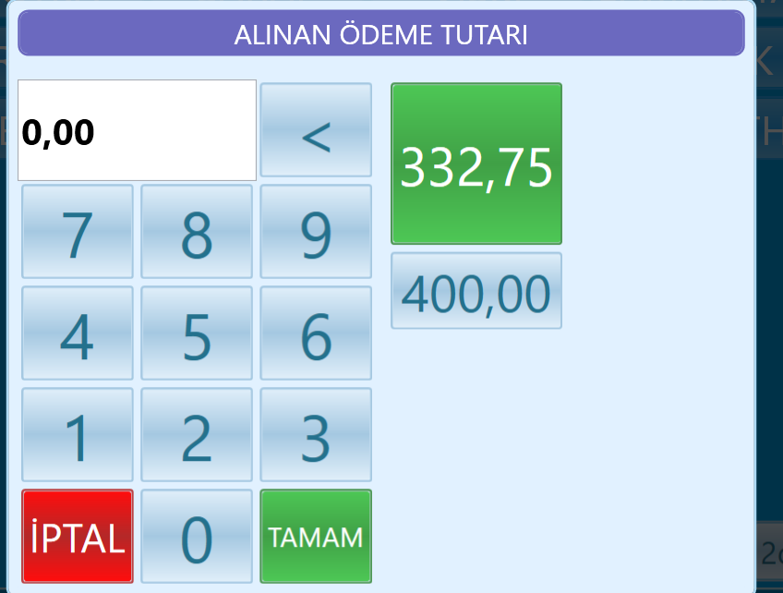
--Ödənişlər cədvəli
Table: SELECT AutoID, OrderPaymentID, PaymentKey, OrderID, OrderKey, StationID, CustomerID, CustomerEmployeeID, CouponNumber, RegisterSessionID, RevenueCenterTypeID, PaymentDateTime, EmployeeID, RegisterNo, PaymentMethodID, AmountTendered, AmountPaid, AmountChange, ExhangeRate, RoundingAmount, CurrencyID, IsAccountPayment, IsAccountSale, PaymentMethodCode, PaymentNotes, LineDeleted, DeleteReason, CustomField1, CustomField2, CustomField3, CustomField4, CustomField5, EditKey, SyncKey, BranchID, AddUserID, AddDateTime, EditUserID, EditDateTime, DayEnd, CustomerEmployeeKey, CustomerKey, EmployeeKey, PaymentMethodKey, AddUserName, EditUserName, EmployeeName, PaymentMethodName, SendOK, RetailData, GlobalBankCode, ingenico, RegisterSessionKey, AccountingCode, BankAccountingCode, IncomeAccountingCode, GlobalBankName, PosVersion, ModuleVersion, PaymentStatus, IntegrationApprove, IntegrationReferenceNo, TsmUsed, OmerdConfirmationId, RefundDetail, IntegrationCardNumber, Pan FROM OrderPayments WHERE (OrderID = 54296)
--ODeme Tipleri
SELECT AutoID, PaymentMethodID, PaymentName, IsDefault, DenyInvoice, DenyFiscal, DenyMoneyChange, ExchangeRate, AccountingCode, SecurityLevel, IsLocked, PaymentMethodActive, EffectRegister, IsCoupon, IsAccountPayment,
IsAccountSale, HideInRecievePayement, PictureName, DisplayIndex, ButtonColor, PaymentMethodKey, BranchID, EditKey, SyncKey, IsCampusCard, CampusCardServer, AskCustomerName, ForcedInvoice, FiscalPaymentName,
FiscalPaymentID, PaymentTypeID, CustomField1, CustomField2, CustomField3, CustomField4, CustomField5, SendOK, GlobalBankCode
FROM PaymentMethods
ÇEK Kapanda basanda
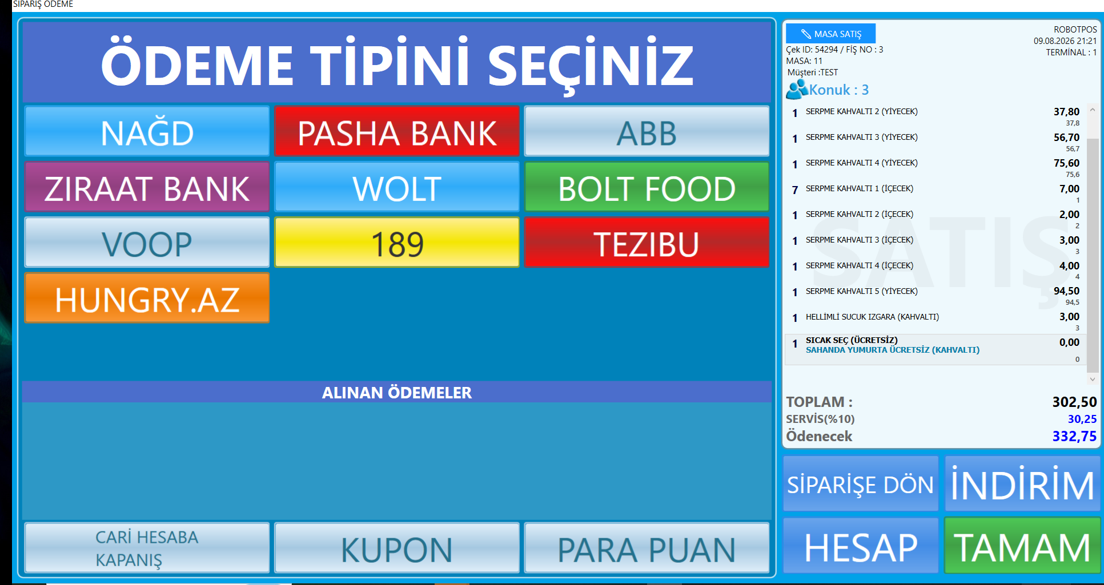
Tamam – Deyəndə sifariş yadda saxlayır.
TAKE AWAY
İlk şəkildə digər satış növümüz PAKET SATIŞ dır amma Şəkildə ŞARKUTERİ-Dir.
Göründüyü kimi hər şey eynidir amma Burada birbaşa ödəniş alınır Masaya ehtiyac olmadığı üçün.
PAKET SATIŞ
Bölməyə girdikdə Telefon nömrəsi istəyir.
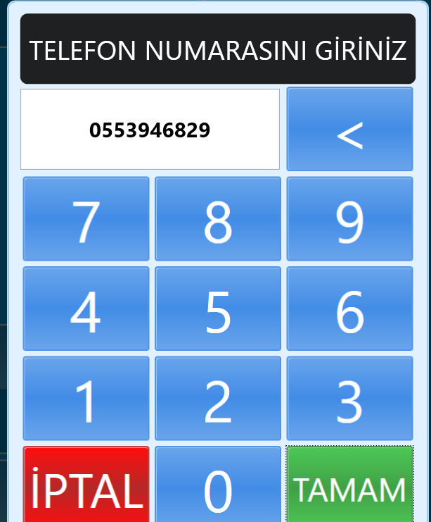
Var olan nömrəyə uyğun MÜŞTƏRİLƏR Görünür. Müştəri məlumatları əks olunur əvvəlcədən qeyd olunubsa görünür məlumatlar və ya yeni daxil edilir.
Table: CustomerFiles
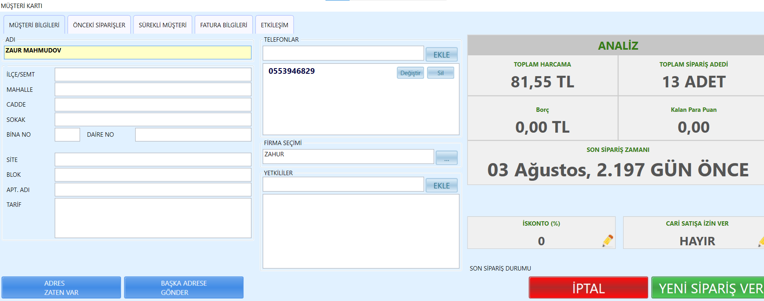
ÖNCEKİ SİPARİŞLƏR
Table: OrderHeaders, OrderTransactions Cədvəlləri.
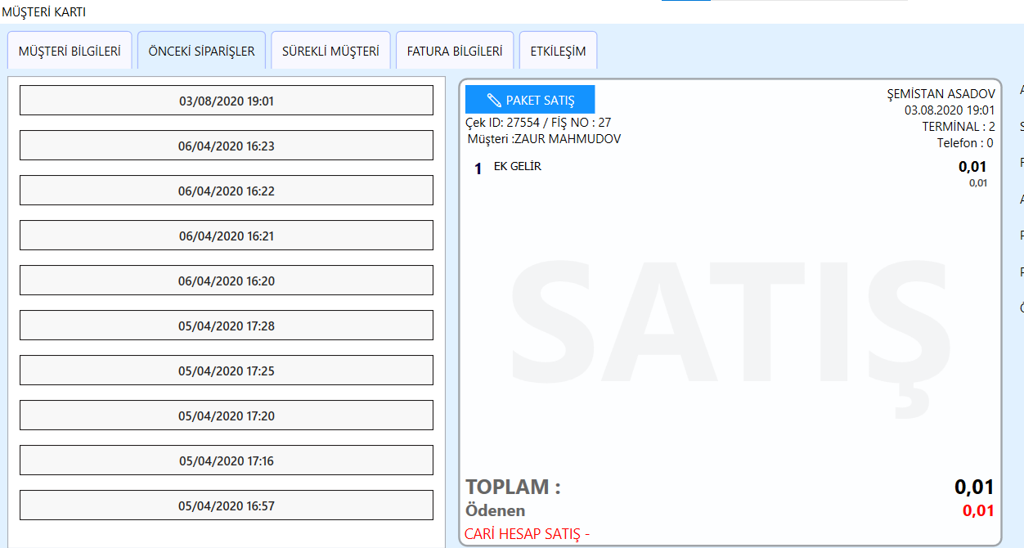
SÜREKLİ MÜŞTERİ
Table: CustomerFiles
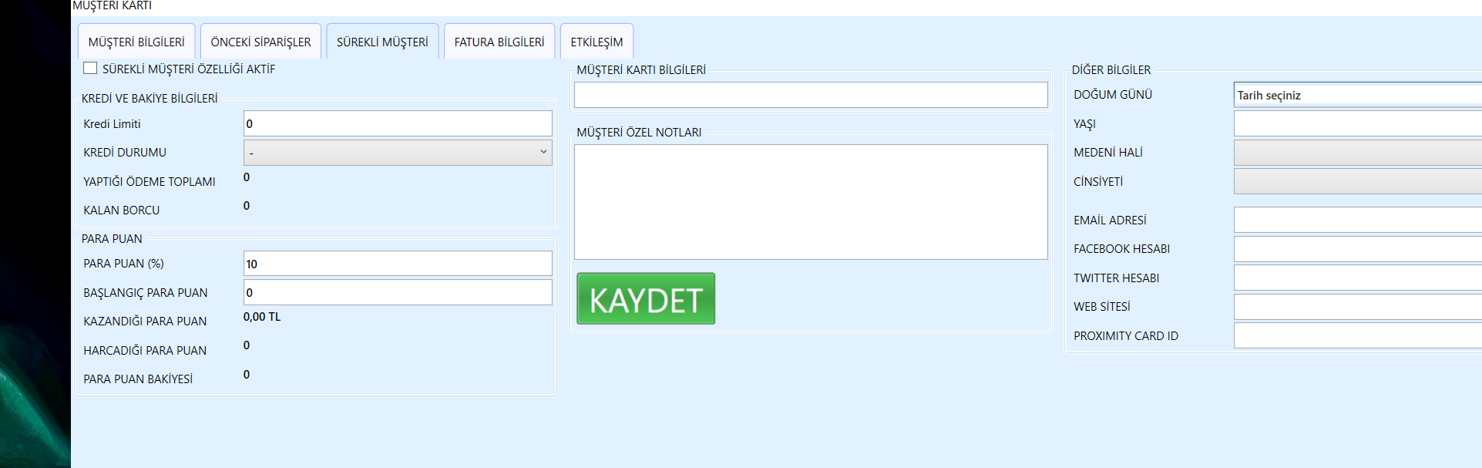
Və bu məlumatlar yerləşir.
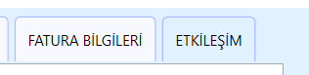
Məlumatlar qane etdikdən sonra YENİ SİPARİŞ VER dediyimizdə yenə eyni Satış Ekranı görünür.
Amma Paket sifarişi olduğundan TAMAM Düyməsinə basdıqda dərhal ödəmə tipinə yönləndirir.
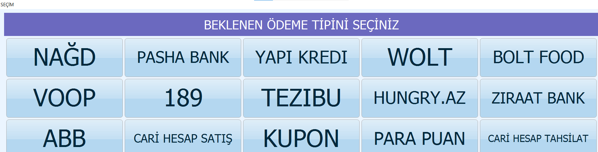
ÇAĞIR
Çağır düyməsinə basdıqda – çelər görünür. Açıq Çeklər Tüm Çeklər, ÇEK NO-ya görə axtarış,satış növlərinə görə çeklər BENİM ÇEKLƏRİM Vəsairə var.
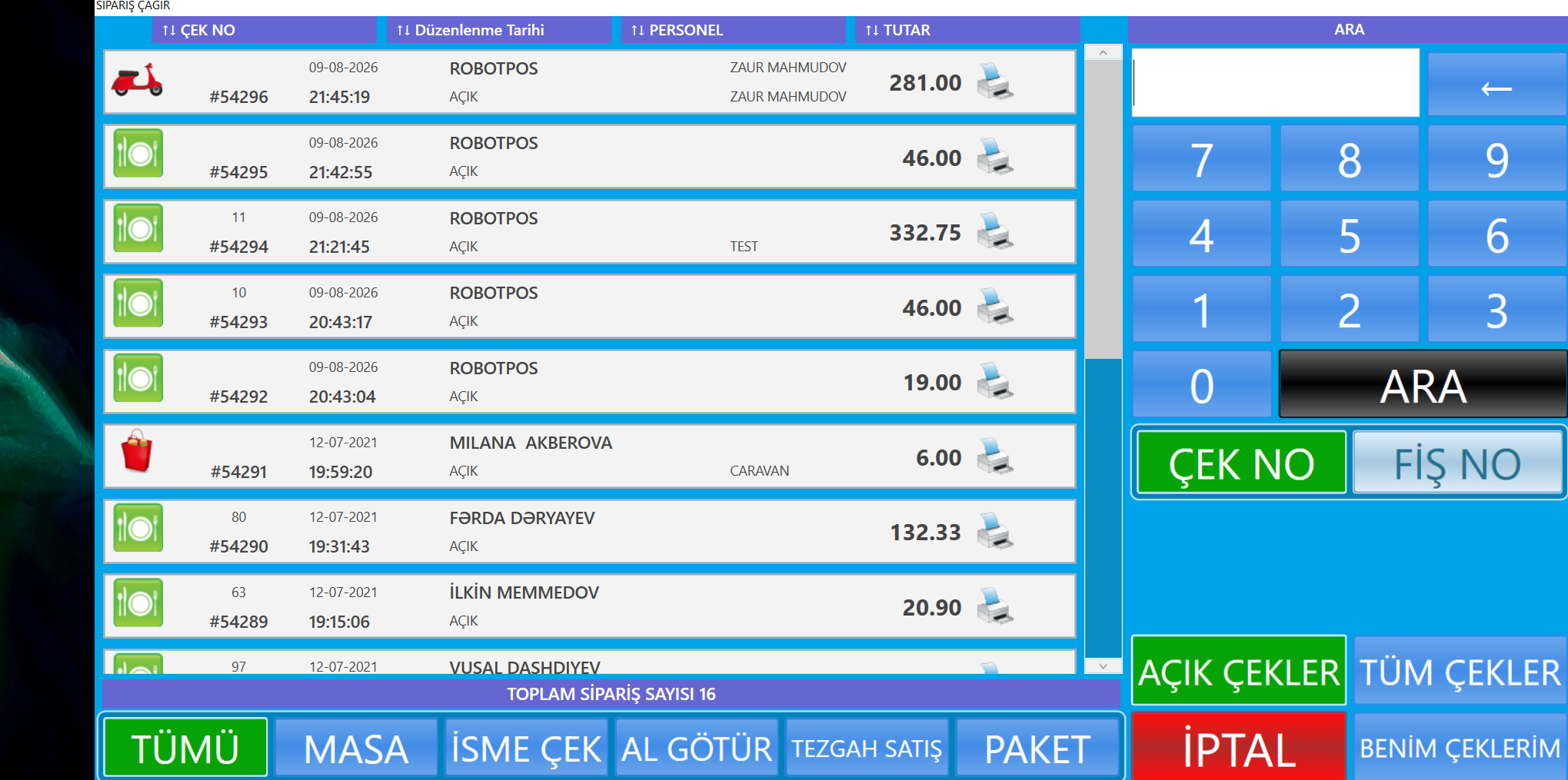
Hər hansı çekin üzərinə basdıqda isə bu ekran açılır.
Table: OrderHeaders, OrderTransactions, PaymentMethods Cədvəlləri.
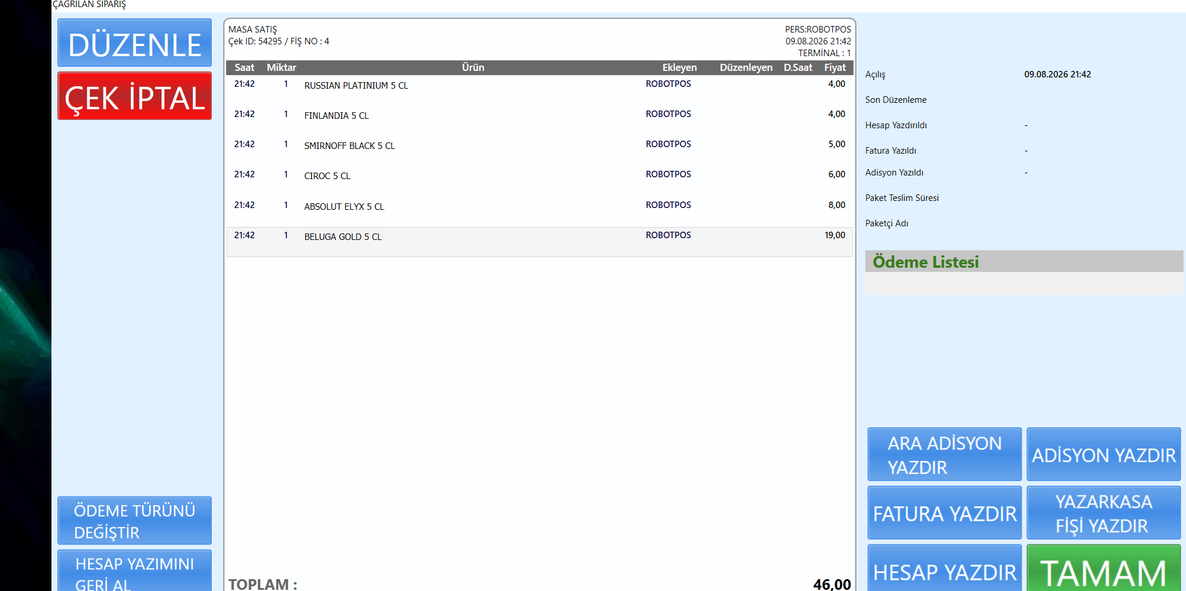
DÜZƏNLƏ – Dedikdə Uyğun satış növünə uyğun SATIŞ EKRANI Açılır hansı ki, bütün satış növlərində olan məlum satış ekranı və istədiyimiz düzəlişi edirik.
ÖDEME TÜRÜNÜ DEĞİŞTİR – Dedikdə ödəmə növünü dəyişə bilirik.
HESAP YAZIMINI GERİ ALMA -Hesabın ödənişini silrərək onu satış statusuna qaytarır məsələn Masa sifarişi idisə MASAYA Qayıdır sifariş.
ADİSYON YAZDIR, HESAP YAZDIR-Məsələn bu funksinallıqlar da var. Onlar da hesab yazdırır.

Ana Ekranda – İşlemler bölməsi
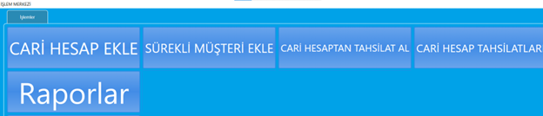
Burada bu funksinallıqlar var. CARİ HESAP EKLE (Paket servisdə də var idi).
SÜREKLİ MÜŞTERİ EKLE (Eyni yerdən idarə olunur sürekli müştəri çeki aktiv olur.
CARİ HESAPTAN TAHSİLAT AL – Müştəri seçib,Ödəmə Növünü Seçirik - Ödəniş alırıq bu hesaba yüklənir sonra istifadə edə bilirik.
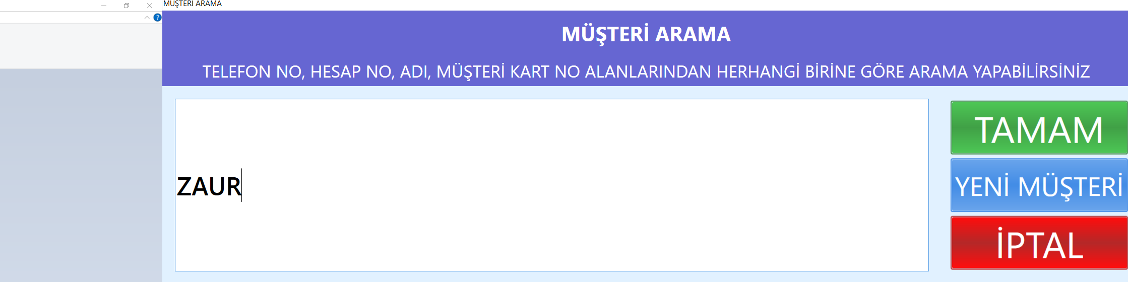
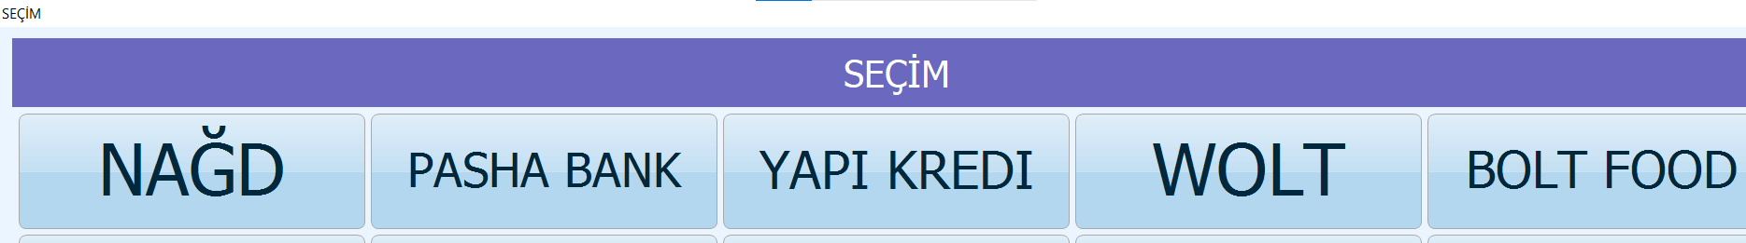
CARİ HESAP TAHSİLATLARI -Aldığımız Tahsilatlar (Ödənişlər) – Burada görünür.
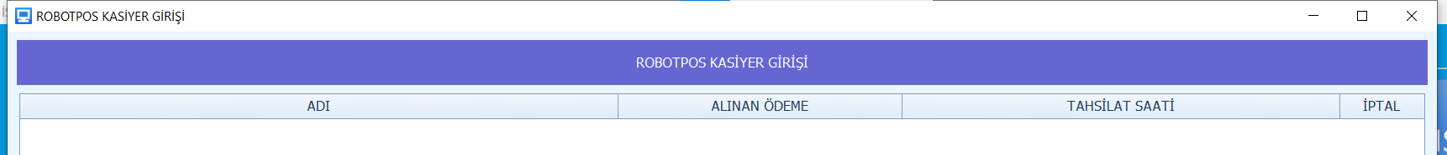
RAPORLAR
Bu cür hesabatlar var.
Table:
Raporlar
SELECT AutoID, ReportID, ReportKey, ReportName, ReportCategoryID, ReportActive, SecurityLevel, ReportTypeID, IsPosReport, EditKey, SyncKey FROM Reports
--Rapor Kateqoriyalari
SELECT ReportCategoryID, CategoryName, MainCategoryID, EditKey, SyncKey
FROM ReportCategories
--Rapor Dizaynlari
SELECT AutoID, ReportDesignID, ReportDesignKey, ReportID, ReportKey, DocumentTypeID, DesignName, DesignData, IsDefault, EditKey, SyncKey
FROM ReportDesigns
---Rapor Sorgulari
SELECT AutoID, ReportQueryID, ReportQueryKey, ReportID, ReportKey, QueryName, QueryData, IsDefault, EditKey, SyncKey
FROM ReportQueries
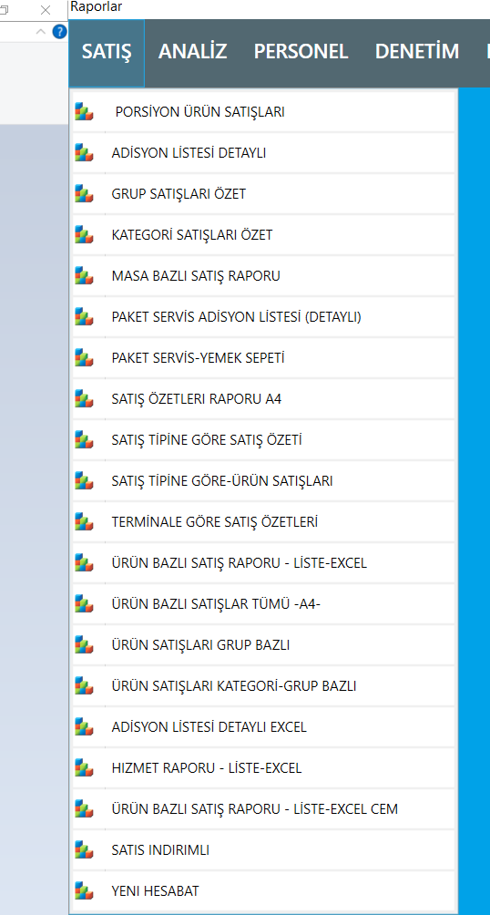
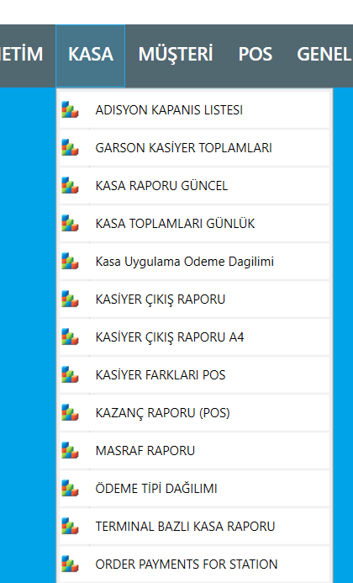
HesaBATI DÜZƏNLƏYƏ BİLƏRİK.
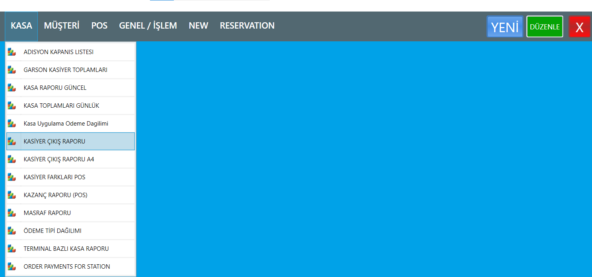
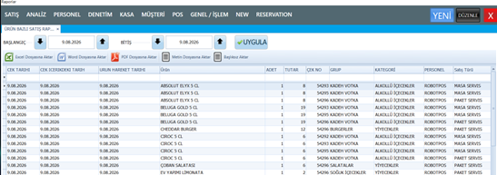
Sol tərəfdə gələn sorğular mərkəzdə parametrik sorğu, yuxarı hissədə rapor adı, hesabatın liste, yəni, siyahı formada olması (bu o mənaya gəlir ki, bu hesabat dizayn tələb etməyəcək), TASARIM Var.
POS-da Çek isə bunun POS Printeri formasında olmasıdır.
Dizayn seçəndə isəbunu report dizaynda yığırıq.
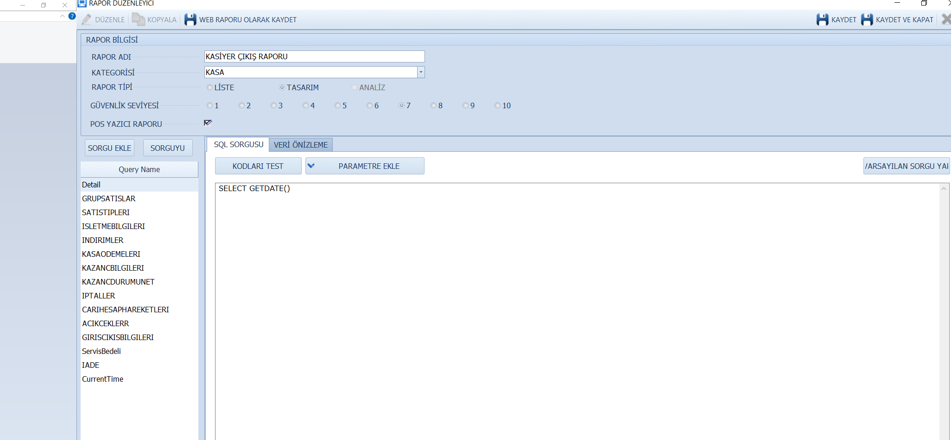
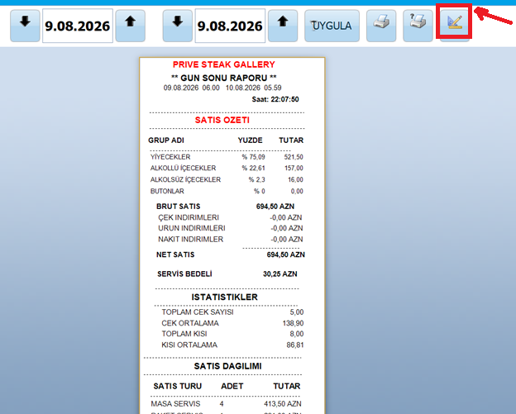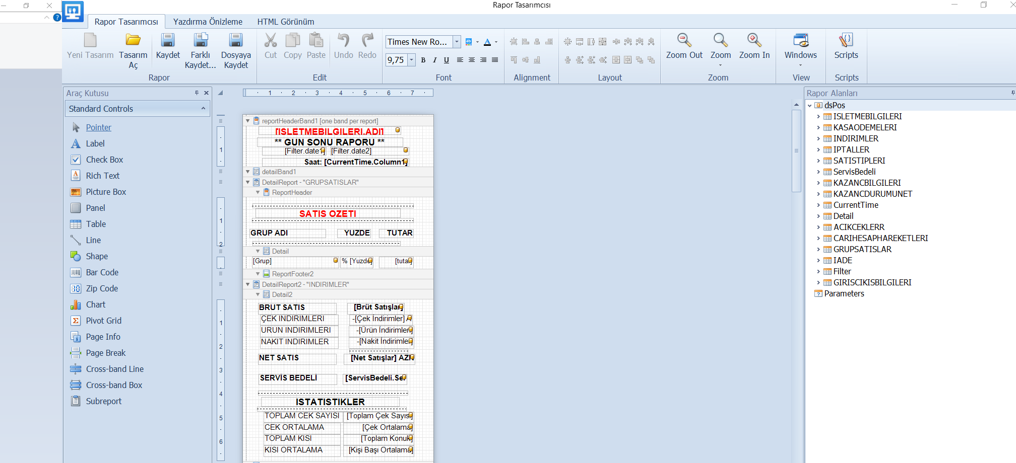

ARKA OFIS
Arka Ofisə girdikdə birinci sazlama Genel Ayarlar – İşletme Ayarlarıdır.
Table:
SELECT SettingsID, OrderID, TabName, GroupName, ParamName, ParamKey, ParamValue, DefaultValue, ParamType, EditKey, SyncKey, BranchID, AddUserID, AddDateTime, EditUserID, EditDateTime, AllowEdit FROM StoreSettings
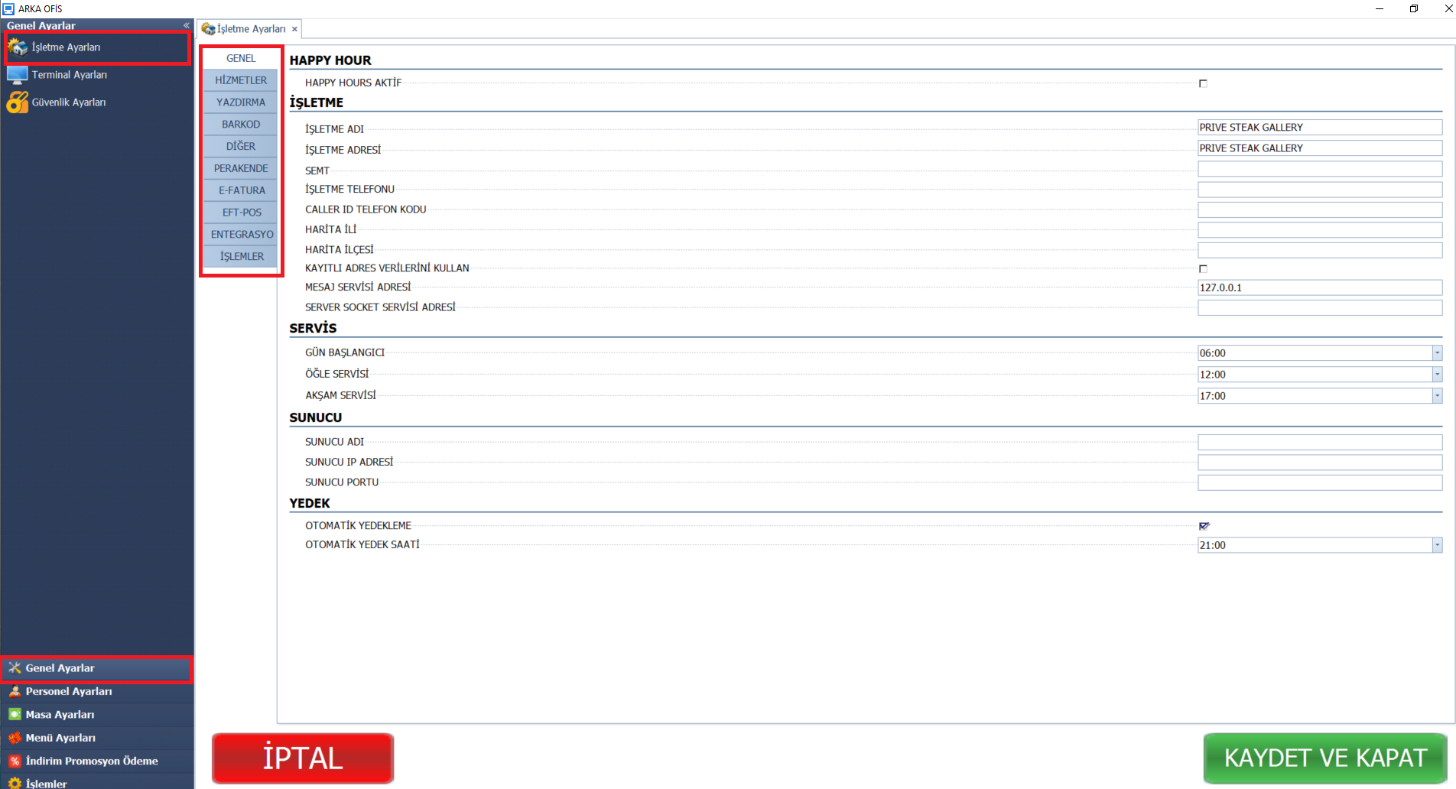

GENEL: Happy Hours aktiv
İŞLETME Haqqında məlumatlar və sairə.
HİZMETLER:
AL GÖTÜR
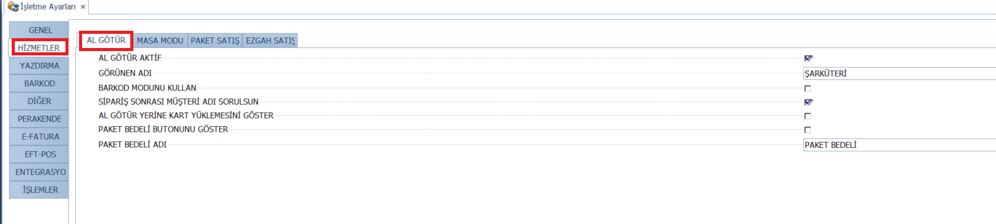
MASA MODU:
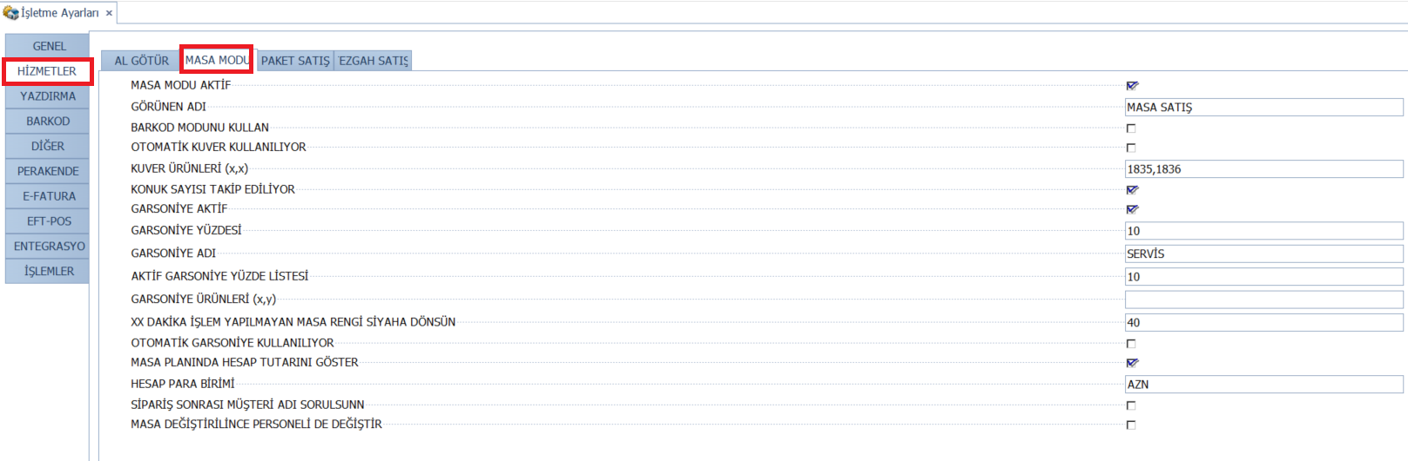
YAZDIRMA:
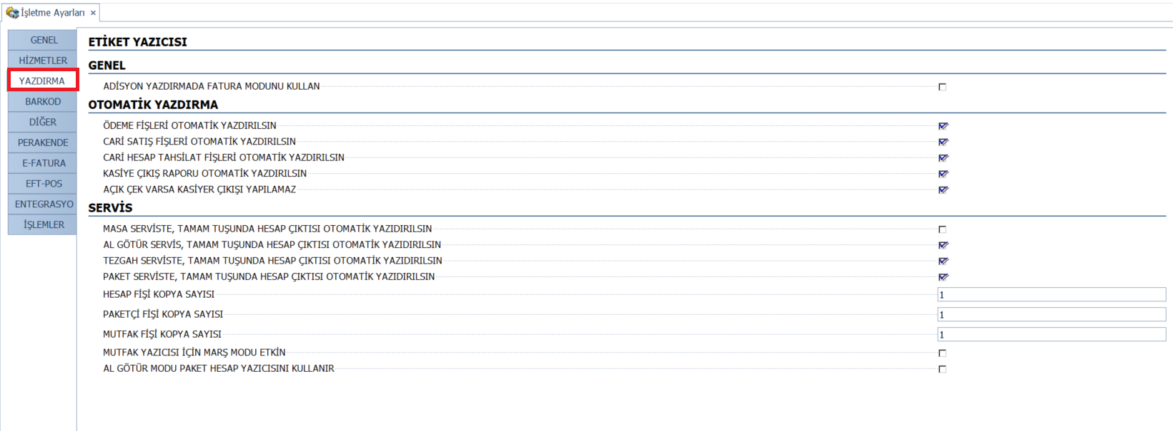
BARKOD:
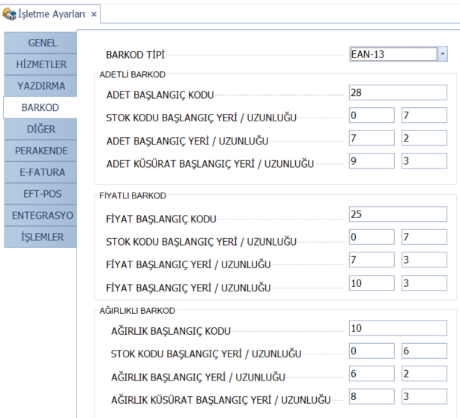

DİĞER:
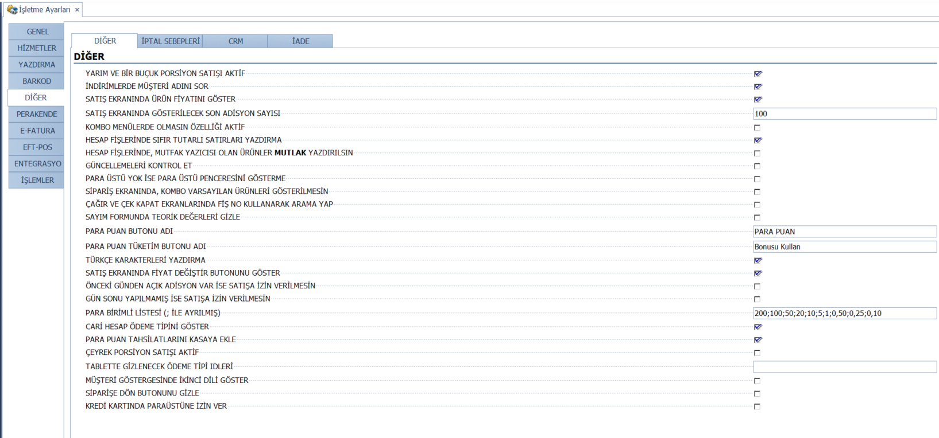

TERMİNAL AYARLARI
SELECT AutoID, StationID, StationName, AllowRegister, DefineValue, ActivateCashier, RememberCashier, BackgroundPicture, SideBarPicture, DefaultLoginEntrance, DefultTablePlan, SkinName, ShowDineInButton, ShowTakeOutButton, ShowDriveThruButton, ShowDeliveryButton, ShowRecallButton, ShowDriverStatusButton, ShowTimeCardButton, ShowOperationsButton, ShowBackOfficeButton, ShowQuickServiceDineIn, ShowQuickServiceTakeOut, ShowQuickServiceDriveThru, ShowQuickServiceDelivery, StayInOrderScreenTakeOut, StayInOrderScreenDriveThru, StayTablePlanInDineIn, TimeOutScreenLock, IsMobile, CustomerDisplayPortNo, CustomerDisplayLine1, CustomerDisplayLine2, WeightScale1PortNo, WeightScale1BaudRate, WeightScale2PortNo, WeightScale2BaudRate, CashRegisterModel, CashRegisterBaudRate, CashRegisterDataDelay, CashRegisterLineDelay, CashRegisterStations, CashRegisterPortNo, PaymentOverTime, DirectOpenOrderInEditMode, PrintVoidedLinesOnGuestCheck, StationKey, AskPasswordForReduce, MediaDisplayIsActive, MediaDisplayOnWaiting, MediaDisplayOnSale, MediaDisplayClosedMessage, MediaDisplayMoneyOver, EditKey, SyncKey, ShowCashTrayButton, DisableSaleOnOpenCashTray, BekoPosDesign, BekoPosOutput, BekoPosDatabase, EnableCallCenterClient, CallCenterClientAddress, KeyNote, ShowScaleOrderDineIn, ShowScaleOrderTakeOut, ShowScaleOrderDriveThru, ShowScaleOrderDelivery, UseRetailMode, HideOkButtonOnQuickService, UseStaticPlu, StaticPluNumber, EnableCentralCallCenterClient, CentralCallCenterClientAddress, UseSecondLangOnKitchenPrint, CallerIDPort, MediaDisplayFontSize, SendTareOnWeightMinus, ShowScaleOrderRetail, SendTareOnAfterAddButton, DefaultWarehouseID, BranchID, ShowComboOnMediaDisplay, ShowMenuModifierOnMediaDisplay, ShowPicturedModifierOnMediaDisplay, ShowSidePictureOnMediaDisplay, ScaleMode, ShowCashDiscountButtonOnMainScreen, SendOK, PosVersion, ViewTotalDiscount, HideOkButtonOnDineIn, HideOkButtonOnDelivery, HideOkButtonOnDriveThru, HideOkButtonOnTakeOut, MediaDisplaySaleOrderPercent, PaymentHideOnDineIn, PaymentHideOnTakeOut, PaymentHideOnDriveThru, PaymentHideOnDelivery, MediaDisplayImagePercent, ShowOtherPaymentType, GarsonStation, VersionInfo, UpdateDateTime, ShowEndOfDayButton, UseVigoServiceOperations, RunPromotionsForMobilApp FROM StationSettings
GENEL:
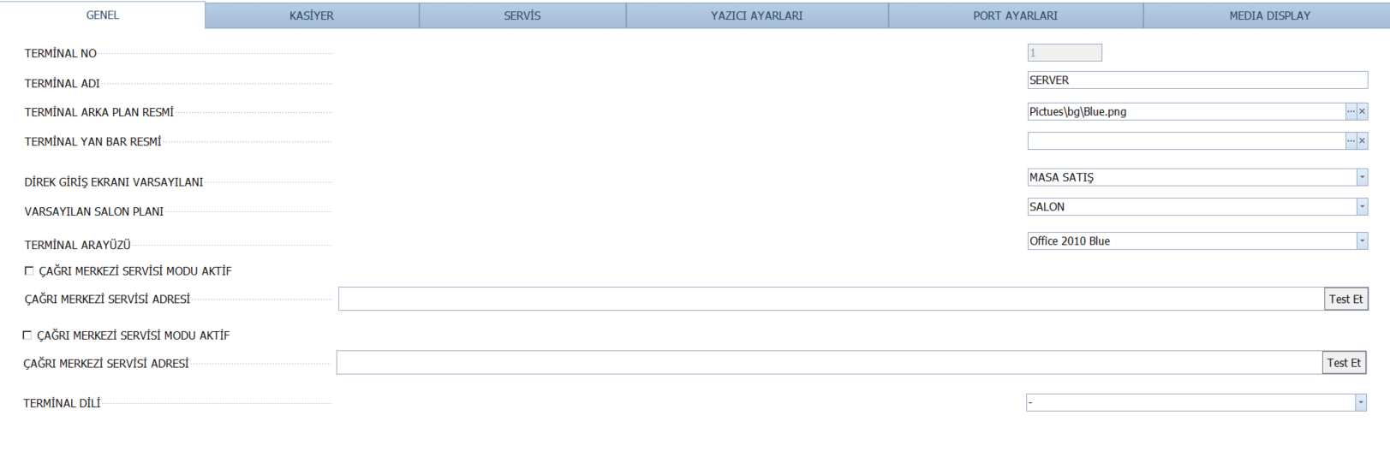
KASİYER:
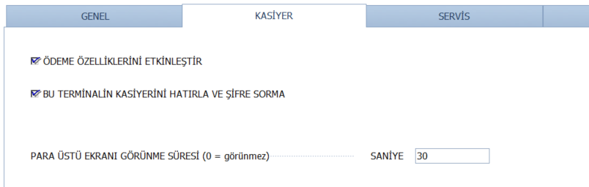
SERVİS:
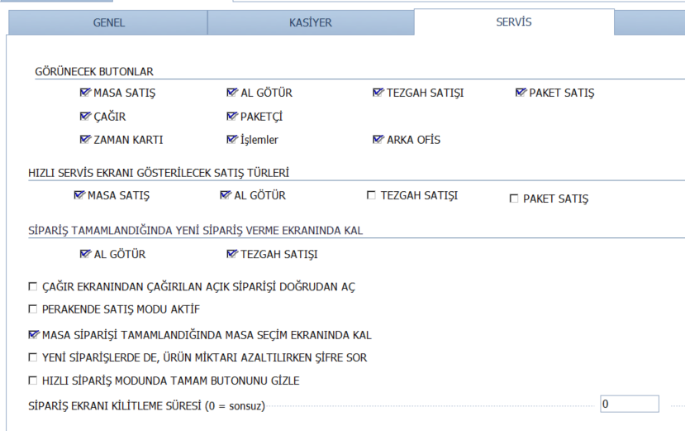
YAZICI AYARLARI:
Table: Printerlər, perinter tənzimləmələri və printer dizaynları.
SELECT AutoID, PrinterID, PrinterName, EditKey, SyncKey FROM Printers
SELECT AutoID, StationID, CheckPrinterName, CheckAltPrinterName, CheckPrinterID, CheckDesignPath, DeliveryPrinterName, DeliveryAltPrinterName, DeliveryPrinterID, DeliveryDesignPath, InvoicePrinterName, InvoiceAltPrinterName, InvoicePrinterID, InvoiceDesignPath, InvoiceRowCount, InvoiceTopFeed, ReportPrinterName, ReportAltPrinterName, ReportPrinterID, ReportDesignPath, AdditionPrinterName, AdditionPrinterID, AdditionDesignPath, AdditionRowCount, AdditionTopFeed, ReportA4PrinterName, ReportA4AltPrinterName, ReportA4PrinterID, ReportA4DesignPath, Kitchen1PrinterName, Kitchen1AltPrinterName, Kitchen1PrinterID, Kitchen1DesignPath, Kitchen2PrinterName, Kitchen2AltPrinterName, Kitchen2PrinterID, Kitchen2DesignPath, Kitchen3PrinterName, Kitchen3AltPrinterName, Kitchen3PrinterID, Kitchen3DesignPath, Kitchen4PrinterName, Kitchen4AltPrinterName, Kitchen4PrinterID, Kitchen4DesignPath, Kitchen5PrinterName, Kitchen5AltPrinterName, Kitchen5PrinterID, Kitchen5DesignPath, Kitchen6PrinterName, Kitchen6AltPrinterName, Kitchen6PrinterID, Kitchen6DesignPath, Kitchen7PrinterName, Kitchen7AltPrinterName, Kitchen7PrinterID, Kitchen7DesignPath, Kitchen8PrinterName, Kitchen8AltPrinterName, Kitchen8PrinterID, Kitchen8DesignPath, Kitchen9PrinterName, Kitchen9AltPrinterName, Kitchen9PrinterID, Kitchen9DesignPath, Kitchen10PrinterName, Kitchen10AltPrinterName, Kitchen10PrinterID, Kitchen10DesignPath, Kitchen11PrinterName, Kitchen11AltPrinterName, Kitchen11PrinterID, Kitchen11DesignPath, Kitchen12PrinterName, Kitchen12AltPrinterName, Kitchen12PrinterID, Kitchen12DesignPath, Kitchen13PrinterName, Kitchen13AltPrinterName, Kitchen13PrinterID, Kitchen13DesignPath, Kitchen14PrinterName, Kitchen14AltPrinterName, Kitchen14PrinterID, Kitchen14DesignPath, Kitchen15PrinterName, Kitchen15AltPrinterName, Kitchen15PrinterID, Kitchen15DesignPath, Kitchen16PrinterName, Kitchen16AltPrinterName, Kitchen16PrinterID, Kitchen16DesignPath, Kitchen17PrinterName, Kitchen17AltPrinterName, Kitchen17PrinterID, Kitchen17DesignPath, Kitchen18PrinterName, Kitchen18AltPrinterName, Kitchen18PrinterID, Kitchen18DesignPath, Kitchen19PrinterName, Kitchen19AltPrinterName, Kitchen19PrinterID, Kitchen19DesignPath, Kitchen20PrinterName, Kitchen20AltPrinterName, Kitchen20PrinterID, Kitchen20DesignPath, PrintDineInOrdersKitchen, PrintBarTableOrdersKitchen, PrintTakeOutOrdersKitchen, PrintDriveThruOrdersKitchen, PrintDeliveryOrdersKitchen, EditKey, SyncKey, LabelPrinterName, LabelPrinterID, LabelDesignPath, PieceProductionDesign, PieceProductionDesignPrint, SemiProductionDesign, SemiProductionDesignPrint, WarehouseTransferDesign, WarehouseTransferDesignPrint, PieceProductionCopy, SemiProductionCopy, WarehouseTransferCopy, ReturnPrinterName, ReturnPrinterID, ReturnDesignPath, PrintOrderAllProductsKitchen FROM StationPrinterSettings
SELECT AutoID, DesignKey, DocumentTypeID, DesignName, DesignData, IsDefault, EditKey, SyncKey
FROM PrinterDesigns
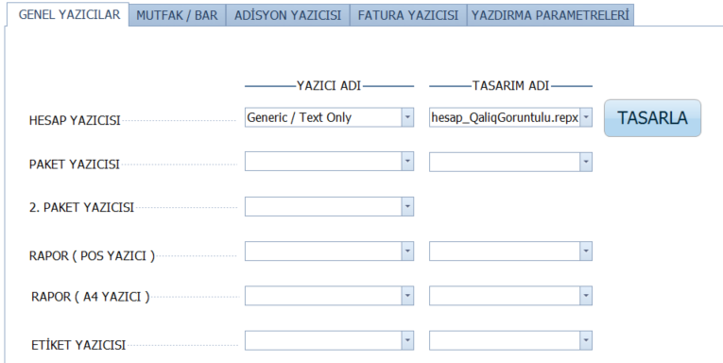
MUTFAK/BAR
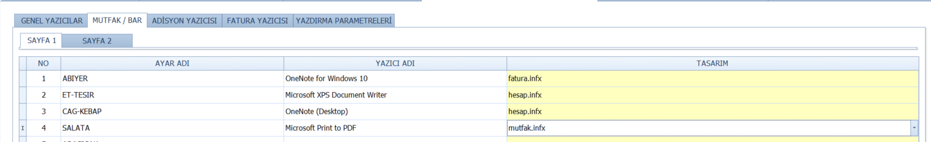
ADISYON YAZICISI:
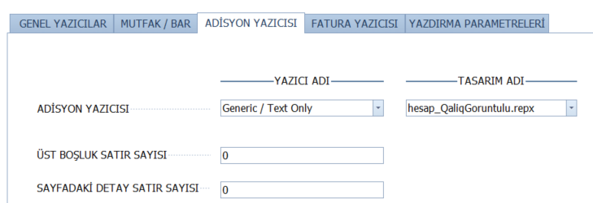

FATURA YAZICISI:
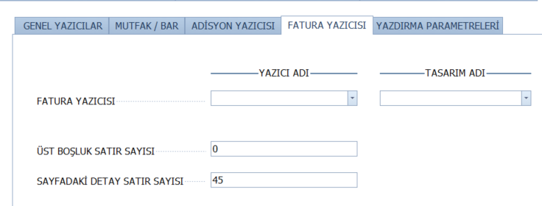

YAZDIRMA PARAMETRELERİ:
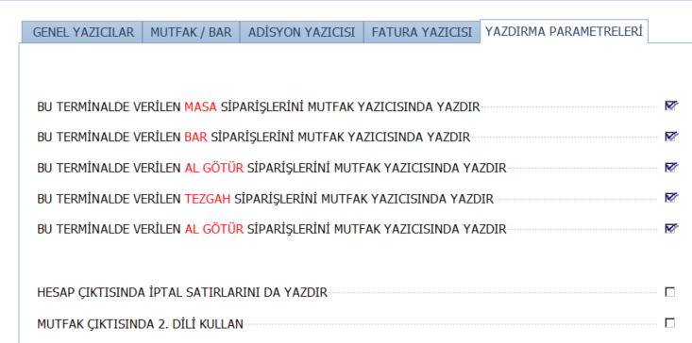

PORT AYARLARI:
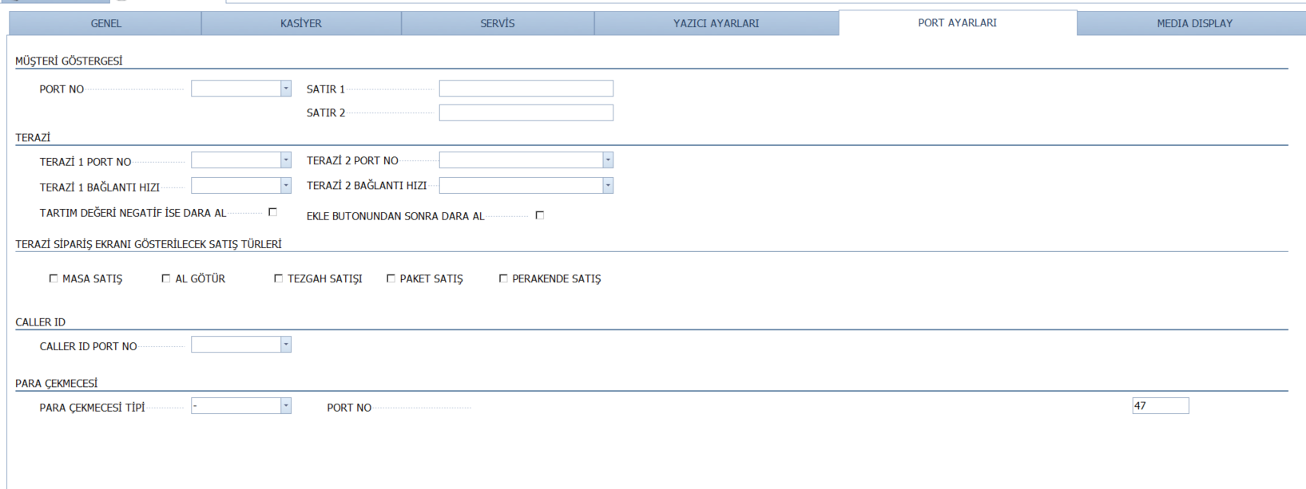
MEDIA DISPLAY:
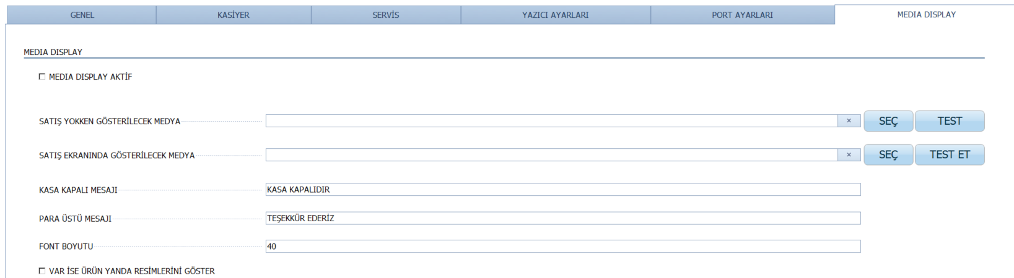

Güvenlik Ayarları
Hər bir sahənin öz güvenlik ayarları var. GENEL,ÖDEME,PAKET,SATIŞ,YAZICI və onlar Zorunlu olub-olmaması Müdir, Kasiyer olaraq ayrılmışdır. Məsələn zorunlu deyəndə həmin yerdə mütləq parol istəyir.
Table:
SELECT AuthorityID, GroupName, AuthorityKey, AuthorityText, AuthorityDescription, DefaultLevel, NeedAllways, AllowManager, AllowCashier, EditKey, SyncKey, BranchID FROM AuthorityList
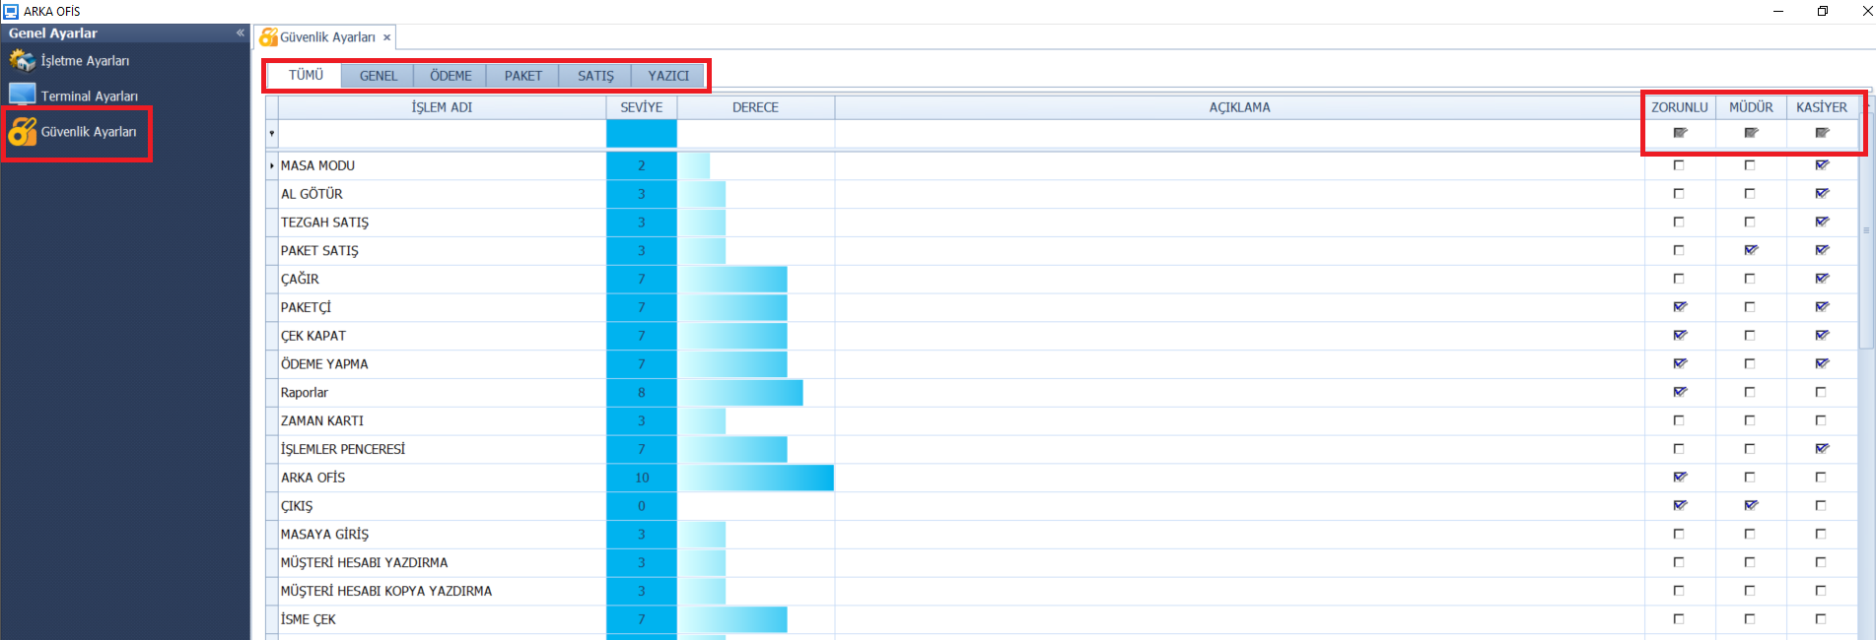
Personel Dosyaları
Table:
SELECT AutoID, EmployeeID, FirstName, LastName, SocialSecurityNumber, MailingAddress, MailingZipCode, SmarCardCode, MifareCardCode, DateHired, DateReleased, EmployeeActive, JobTitleID, SecurityLevel, AccessCode, TipsReceived, PayBasis, PayRate, ScanCode, DriverLicenseNumber, DriverLicenseExpires, CarInsurancePolicyCarrier, CarInsurancePolicyNumber, CarInsurancePolicyExpires, CarInsurancePolicyNotes, PrefUserInterfaceLocale, EmployeeNotes, OrderEntryUseSecLang, EmployeeIsDriver, DefaultOEMenuGroupID, UseStaffBank, ScheduleNotEnforced, UseHostess, IsAServer, IsOffline, NoCashierOut, EditTimestamp, PhoneNumber, RevenueCenterTypeID, DeleteReason, CustomField1, CustomField2, CustomField3, CustomField4, CustomField5, EditKey, SyncKey, BranchID, AddUserID, AddDateTime, EditUserID, EditDateTime, EmployeeKey, MonthlyDinnerFee, SendOK FROM EmployeeFiles
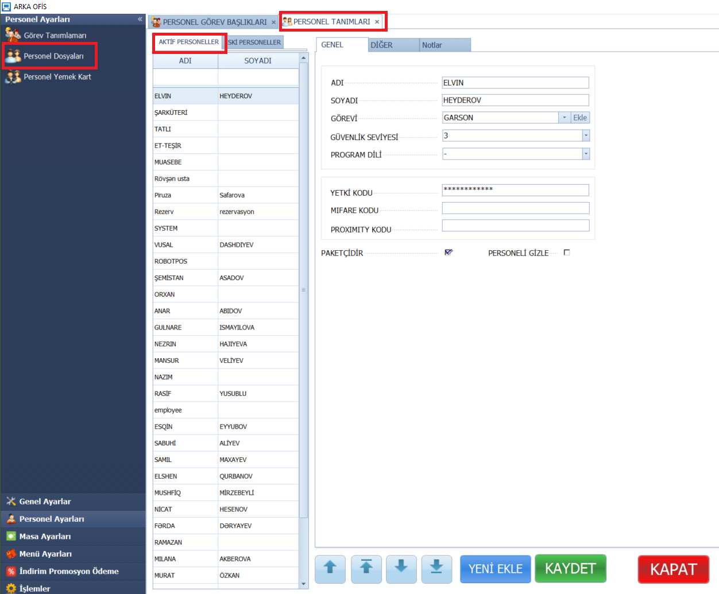

Personel Yemek Kart
SELECT c.AutoID, c.CustomerID, c.CustomerKey, c.CustomerGlobalKey, c.CustomerIsActive, c.CustomerName, c.CustomerFullName, c.CardNumber, c.CustomerNotes, c.OrderCount, c.LastCallDate, c.CallingCount, c.AllowHouseAccount, c.IsFrequentDiner, c.CreditLimit, c.CreditSatusID, c.DiscountPercent, c.SpecialBonusPercent, c.TotalDebt, c.TotalPayment, c.TotalRemainig, c.BonusStartupValue, c.TotalBonusUsed, c.TotalBonusEarned, c.TotalBonusRemaing, c.CityName, c.District, c.Neighborhood, c.Avenue, c.Street, c.Buildings, c.Block, c.Apartment, c.ApartmentNo, c.FlatNo, c.IsDefault, c.TaxOfficeName, c.TaxNumber, c.ZipCode, c.AddressNotes, c.AreaCode, c.CustomerSpecialNotes, c.BirthDay, c.MaritialStatus, c.Age, c.EmailAddress, c.Sexuality, c.FacebookAccount, c.TwitterAccount,
c.WebSite, c.PhotoPath, c.ProximityCardID, c.EditKey, c.SyncKey, c.BranchID, c.LockData, c.LockStationID, c.AddUserID, c.AddDateTime, c.EditUserID, c.EditDateTime, c.OpenValue, c.WebUserName, c.WebPassword FROM CustomerFiles AS c INNER JOIN EmployeeFiles AS e ON c.CustomerKey = e.EmployeeKey where isnull(c.CustomerIsActive,0)=1 AND isnull(e.EmployeeActive,0)=1
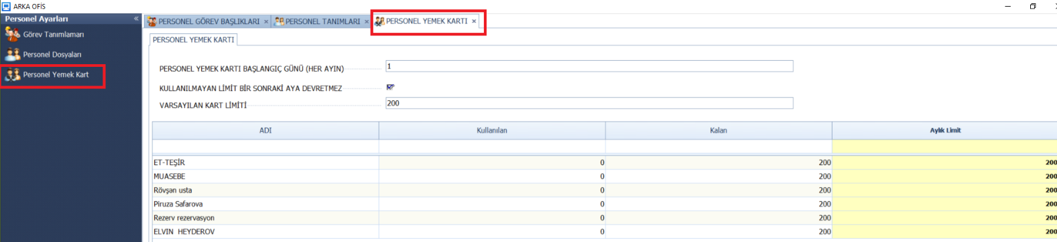

MASA AYARLARI
Masa Qrupları:
Table: DineInTableGroups
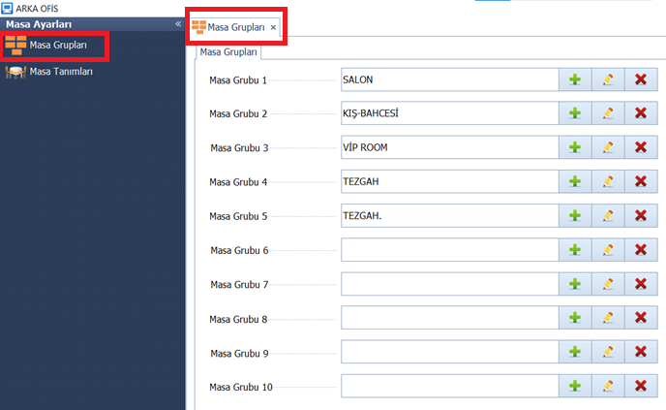
Masa Tanımları:
Table: DineInTables
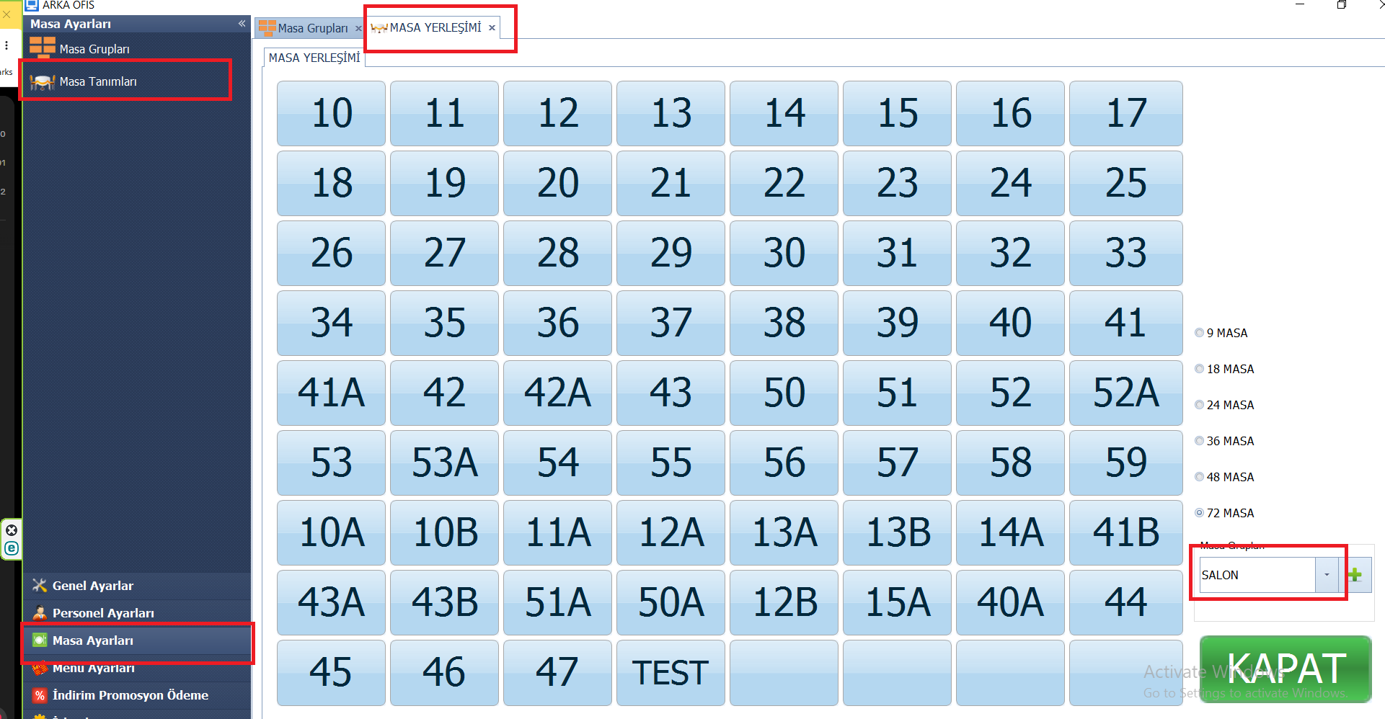

Menü Ayarları
Table: MenuItems, MenuItemLayout, MenuCategories, MenuGroups, MenuSubCategories

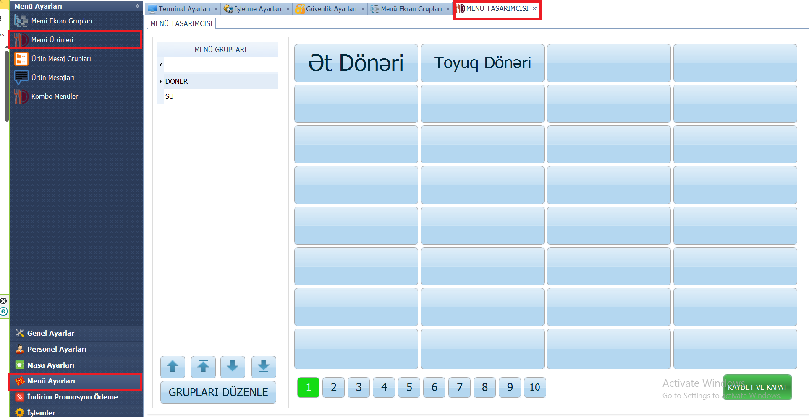

Menü qrupu əlavə etmək:
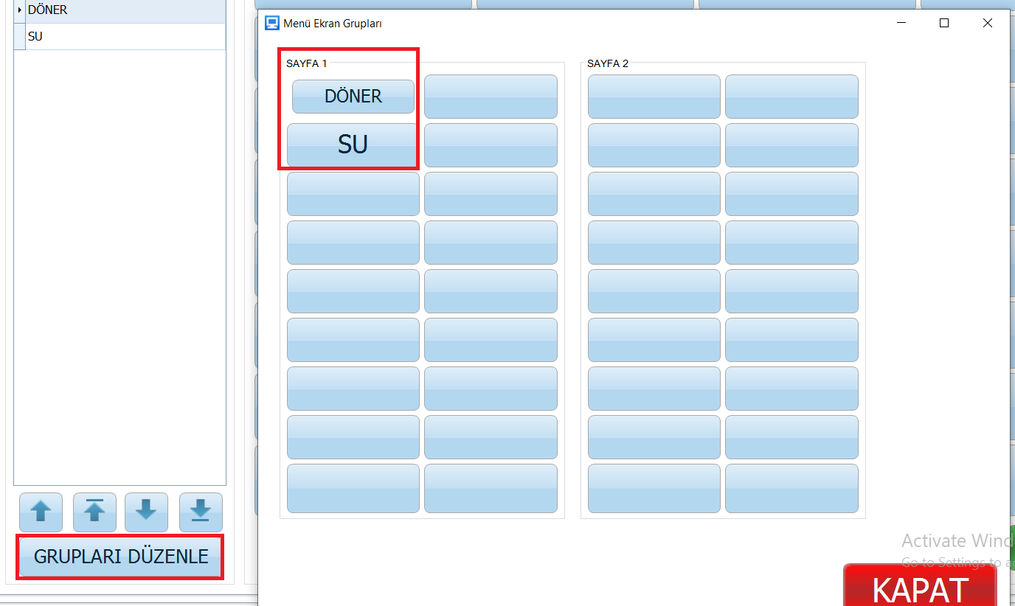
Menü Əlavə etmək:
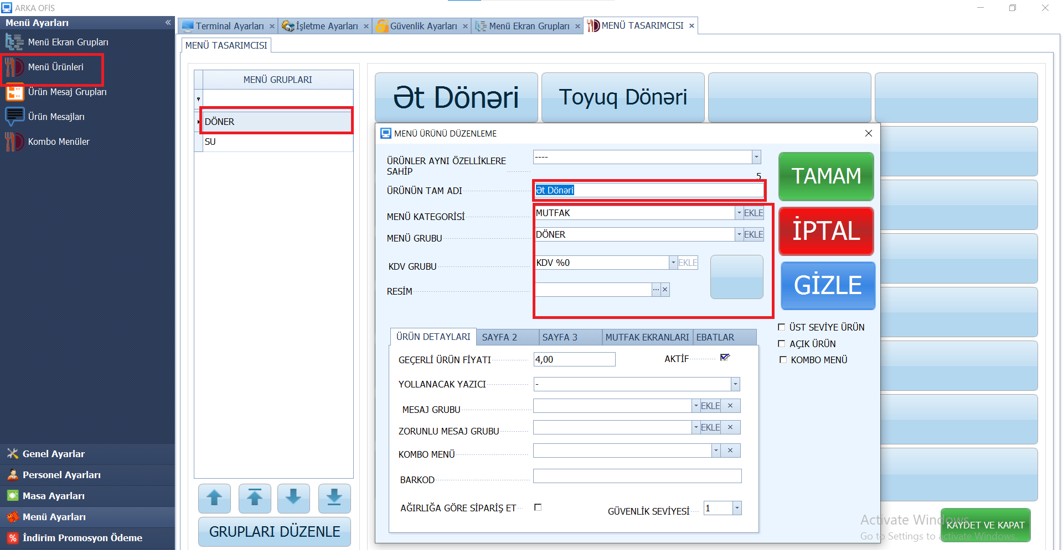
ÜRÜN DETAYLARI:
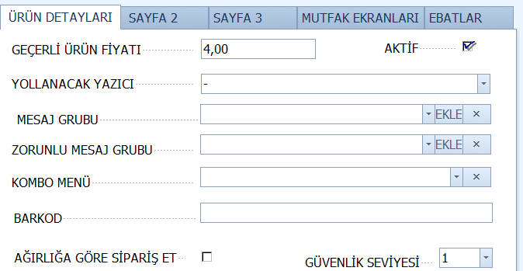
Table: Modifikasiyalar və modifikasiya qrupları:
SELECT MenuModifierID, MenuModifierText, AdditionalCost, MenuModifierActive, SecLangModifierText, PictureName, ShowCaption, PizzaCrust, PizzaTopping, BarMixer, IsKdsAddition, IsKdsSent, SecurityLevel, DeleteReason, CustomField1, CustomField2, CustomField3, CustomField4, CustomField5, EditKey, SyncKey, BranchID, AddUserID, AddDateTime, EditUserID, EditDateTime, MenuModifierKey, DepositWeight, OrderByWeightAddProduct FROM MenuModifiers
SELECT AutoID, BranchID, MenuModifierGroupID, MenuModifierID, DisplayIndex, IsSelected, MenuModifierLayoutKey, MenuModifierGroupKey, MenuModifierKey, EditKey, SyncKey FROM MenuModifierLayout
SELECT MenuModifierGroupID, MenuModifierGroupText, DisplayIndex, MenuModifierGroupActive, SecLangMenuModifierGroupText, PictureName, ButtonColor, RevenueCenterTypeID, DeleteReason, CustomField1, CustomField2, CustomField3, CustomField4, CustomField5, EditKey, SyncKey, BranchID, AddUserID, AddDateTime, EditUserID, EditDateTime, MenuModifierGroupKey FROM MenuModifierGroups

SAYFA 2:
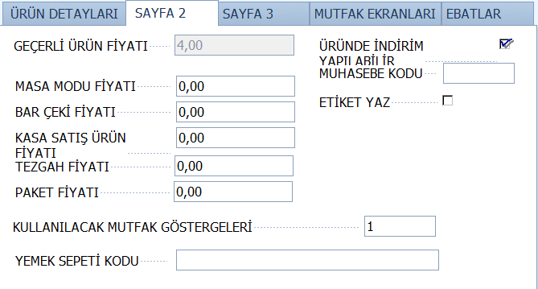

SAYFA 3:
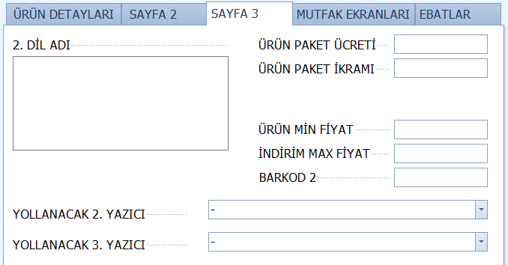
SAYFA 4:
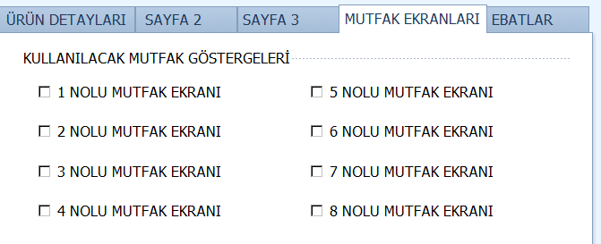
EBATLAR:
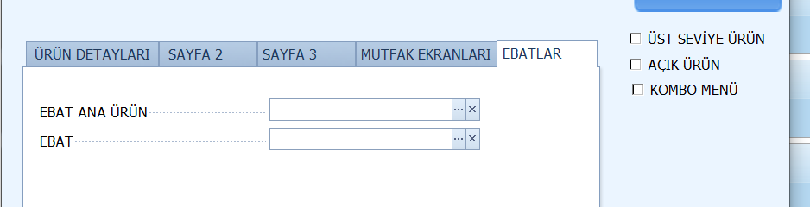

Ürün Mesajları:
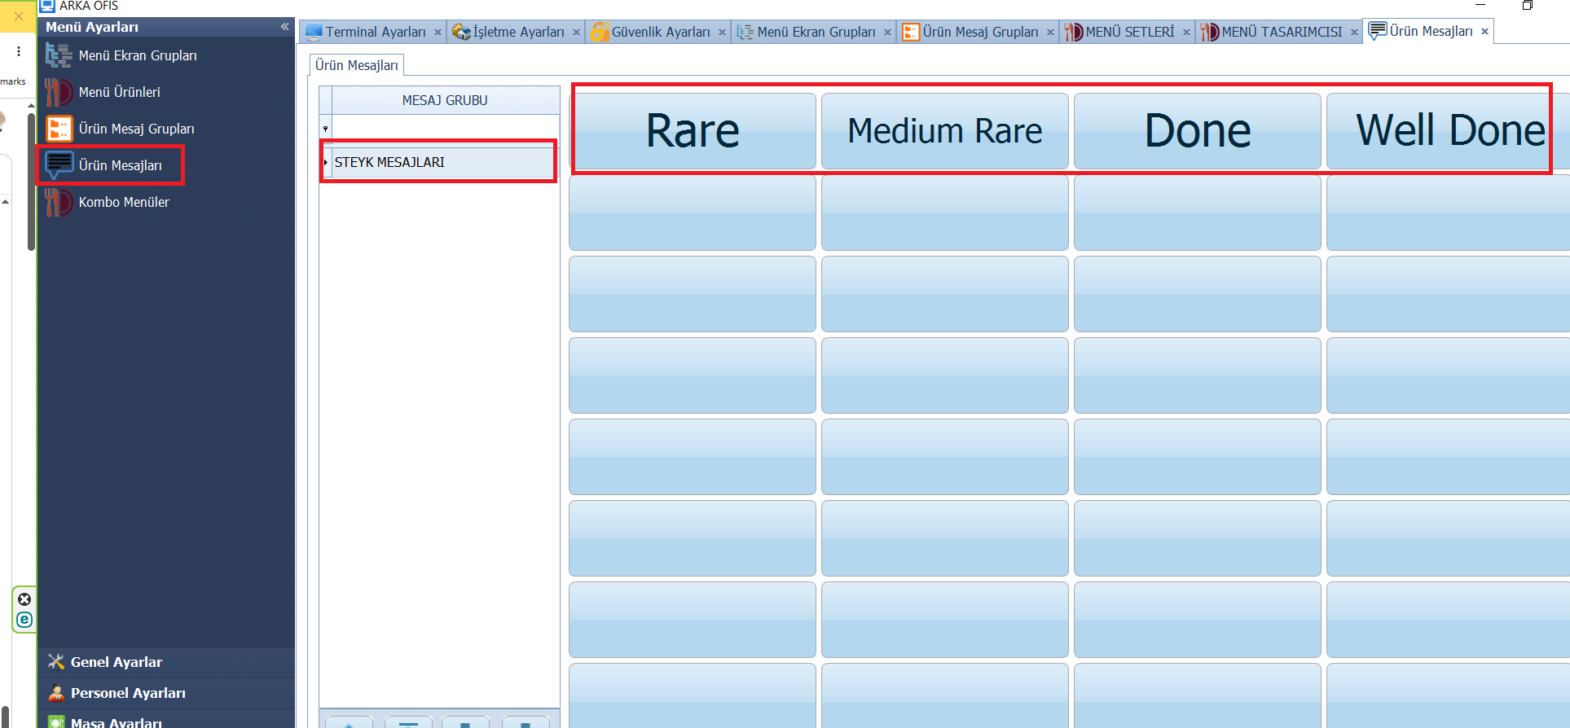

İndirim Promosyon Ödeme
İndirim Promosyon Ödeme – İndirim Ayarları:
Table: Discounts Cədvəli yuxarda təqdim edilib və Endirim Filteri cədvəli: DiscountFilter
SELECT AutoID, DiscountKey, MenuGroupKey, MenuItemKey, BranchID, IsSaleFilter FROM DiscountFilter
Genel:
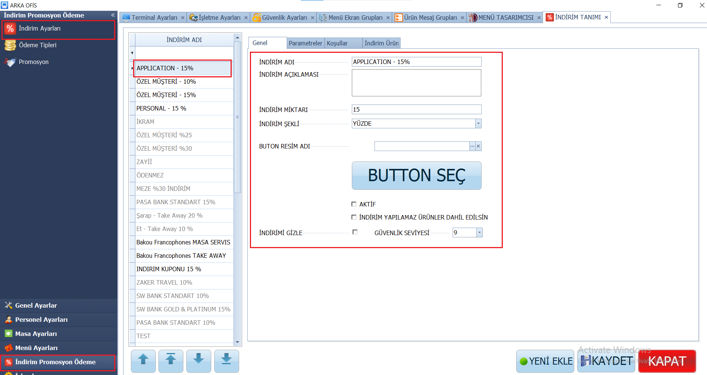
Parametreler:
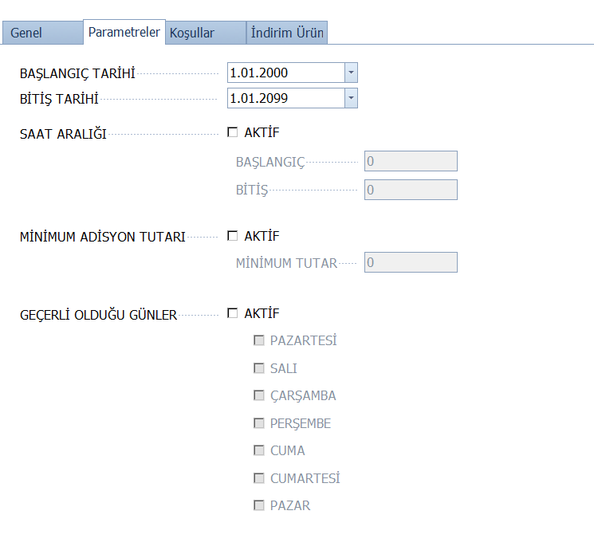
Koşullar:
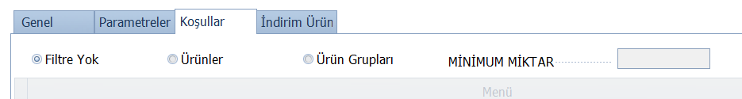

İndirim Ürün:
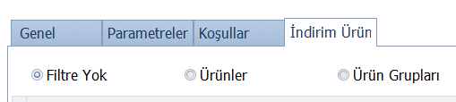

İndirim promosyon ödeme – Ödeme Tipleri:
Table:PaymentMethods
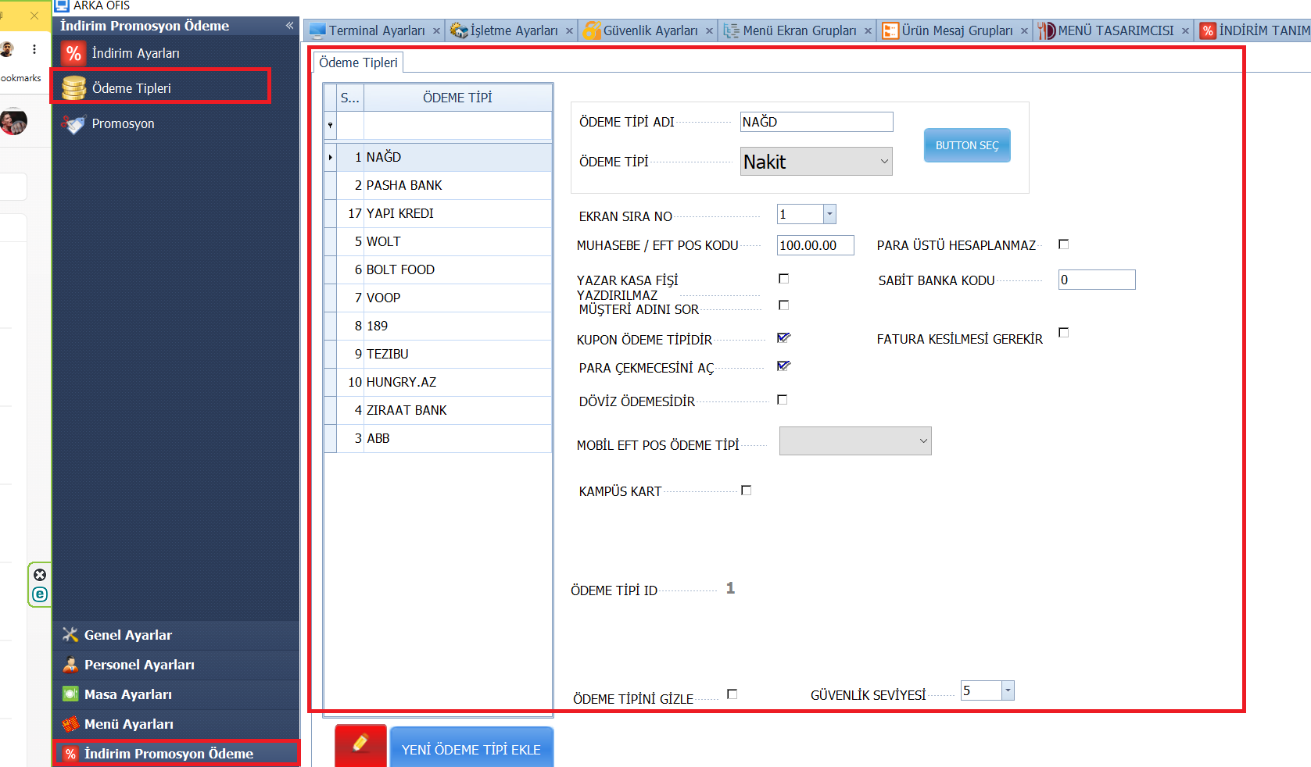

İndirim promosyon ödeme – Promosyon: Discounts Cədvəli:
SELECT PromotionID, PromotionKey, PromotionName, PromotionNotes, IsActive, UseAuto, MenuGroupKey, MenuGroupCondition, MenuGroupMinSale, MenuItemKey, MenuItemsCondition, MenuItemsMinSale, StartDate, EndDate, StartHour, EndHour, SaleTypes, SaleTypeCondition, Stations, StationCondition, Days, DayCondition, Employees, EmployeeCondition, CustomerGroup, CustomerGroupCondition, PaymentTypes, PaymentTypeCondition, GiftMenuGroupKey, GiftMenuGroupContidion, GiftMenuGroupQuantity, GiftMenuItemKey, GiftMenuItemsCondition, GiftMenuItemQuantity, GiftMenuDiscountAmount, GiftMenuDiscountPercent, GiftOrderDiscountAmount, GiftOrderDiscountPercent, GiftStaticPrice, GiftBonusPercent, EditKey, SyncKey, BranchID, AddUserID, AddDateTime, EditUserID, EditDateTime, MenuItemKeyList, MinimumOrderAmount, PromotionPriority, AllowJointlyUse, GiftMenuItemKeyList, IgnoredPromotionKeys FROM Promotions
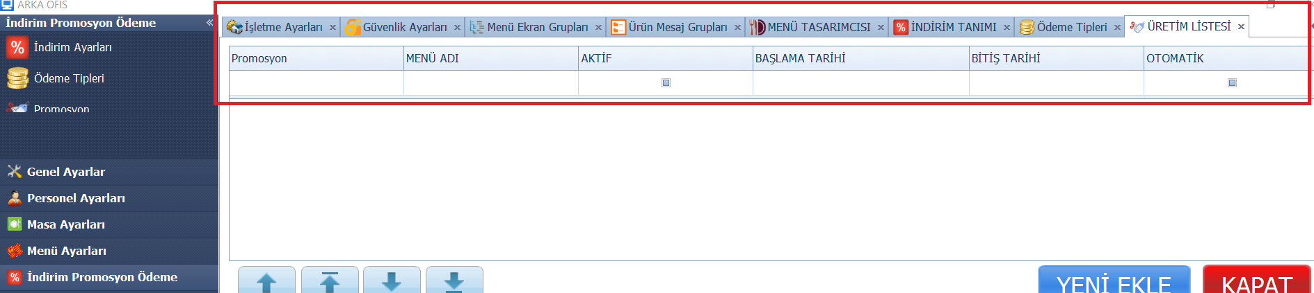

İŞLEMLER
Yemet Sebeti Eşleşme
Table:
SELECT AutoID, MenuItemKey, MenuItemText,'' AS YemekSepetiText,isnull(SecLangMenuItemText,'') AS YemekSepetiSKU,'' AS oldYemekSepetiText,0 as IsRepeated FROM MenuItems ORDER BY MenuItemText
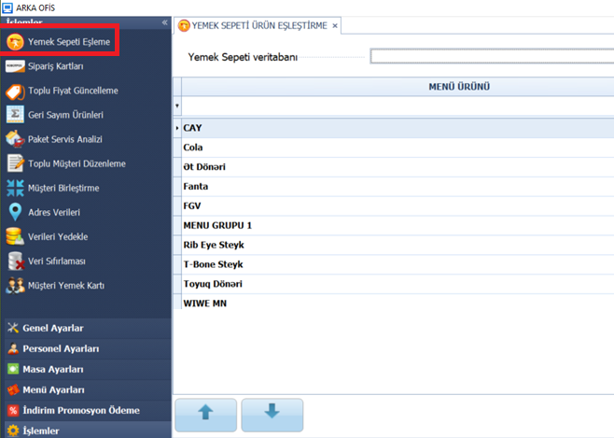

Sifariş Kartları:
Table:
SELECT [AutoID] , [CardName] , [CardNumber] , [CardName] as oldCardName , [CardNumber] as oldCardNumber FROM [OrderCards]
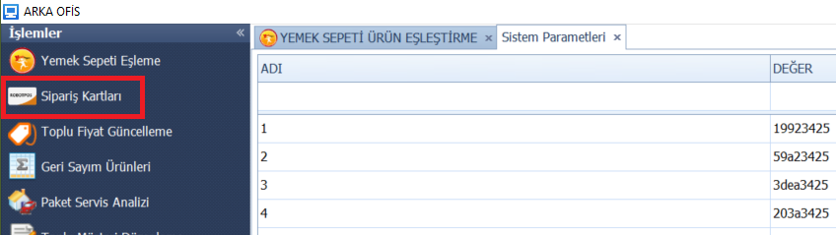
Toplu fiyat güncelleme:
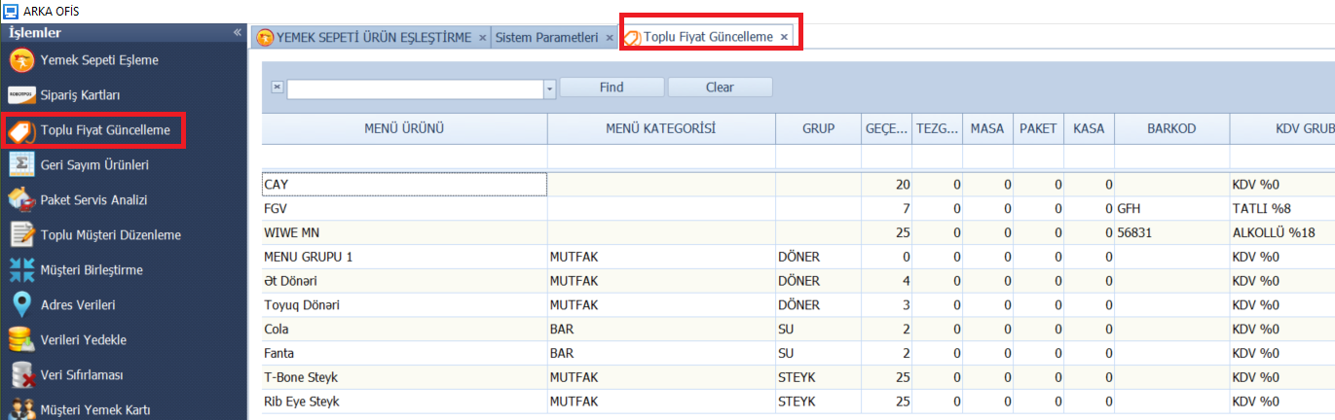
SELECT MenuItems.AutoID, MenuItems.MenuItemID, isnull(MenuItems.MainMenuItemID,0) as MainMenuItemID, MenuItems.RevenueCenterTypeID, MenuItems.MenuItemText, MenuItems.MenuCategoryID,
MenuItems.MenuGroupID, MenuItems.DisplayIndex as DisplayIndex, MenuItems.DefaultUnitPrice, MenuItems.MenuItemCost, MenuItems.MenuItemDescription,
MenuItems.MenuItemNotification, MenuItems.MenuItemActive, MenuItems.MenuItemInStock, MenuItems.MenuItemTaxable, isnull(TaxGroups.TaxRate,8) AS TaxPercent,
MenuItems.MenuModifierID, MenuItems.MenuItemDiscountable, MenuItems.MenuItemPopUpHeaderID, MenuItems.MenuItemPopUpChoiceText,
MenuItems.HasModifierPopUps, isnull(MenuItems.SecLangMenuItemText,'') as SecLangMenuItemText, MenuItems.SecLangPopUpChoiceText, MenuItems.PictureName, MenuItems.ShowCaption,
isnull(MenuItems.IsComboMenu,0) as IsComboMenu,isnull(MenuItems.IsTopMenu,0) as IsTopMenu, MenuItems.ButtonColor, isnull(MenuItems.Barcode,'') as Barcode,isnull(MenuItems.Barcode2,'') as Barcode2, MenuItems.ItemDelCharge, MenuItems.ItemDelComp,
MenuItems.DineInPrice, MenuItems.BarTabPrice, MenuItems.TakeOutPrice, MenuItems.DriveThruPrice, MenuItems.DeliveryPrice, MenuItems.OrderByWeight,
MenuItems.PrintPizzaLabel, MenuItems.KitchenSortNumber, MenuItems.ModBuilderTemplateID, MenuItems.MenuItemTypeID, isnull(MenuItems.AccountingCode,'') as AccountingCode,
isnull(MenuItems.PrintOnLabel,0) as PrintOnLabel, MenuItems.UsedPrinterID1, MenuItems.UsedPrinterID2, MenuItems.UsedPrinterID3, MenuItems.UsedPrinterID4, MenuItems.UsedPrinterID5,
MenuItems.SecurityLevel, MenuItems.DeleteReason, MenuItems.CustomField1, MenuItems.CustomField2, MenuItems.CustomField3, MenuItems.CustomField4,
MenuItems.CustomField5, MenuItems.EditKey, MenuItems.SyncKey, MenuItems.BranchID, MenuItems.AddUserID, MenuItems.AddDateTime, MenuItems.EditUserID,
isnull(MenuItems.UseKds1,0) as UseKds1, isnull(MenuItems.UseKds2,0) as UseKds2, isnull(MenuItems.UseKds3,0) as UseKds3,isnull(MenuItems.UseKds4,0) as UseKds4,
isnull(MenuItems.UseKds5,0) as UseKds5,isnull(MenuItems.UseKds6,0) as UseKds6,isnull(MenuItems.UseKds7,0) as UseKds7,isnull(MenuItems.UseKds8,0) as UseKds8,
isnull(MenuItems.UseKds9,0) as UseKds9,isnull(MenuItems.UseKds10,0) as UseKds10,
MenuItems.CountDownDate, isnull(MenuItems.CountDownValue,0.0) as CountDownValue,isnull(MenuItems.CountDownActualResult,0.0) as CountDownActualResult, MenuItems.EditDateTime, MenuCategories.MenuCategoryText, MenuSubCategories.MenuSubCategoryText, TaxGroups.GroupName AS TaxGroupText,
MenuModifierGroups.MenuModifierGroupText AS MenuModifierText, MenuItems.DisplayIndex AS MenuDisplayIndex, MenuItems.MenuItemKey,
MenuItems.MainMenuItemKey, MenuItems.MenuItemGlobalKey, MenuItems.MenuCategoryKey, MenuItems.MenuGroupKey, MenuItems.TaxGroupID,
MenuItems.TaxGroupKey, MenuItems.MenuModifierKey, MenuItems.MenuModifierForcedID, MenuItems.MenuModifierForcedKey,
MenuForcedModifierGroups.MenuModifierGroupText AS MenuForcedModifierText,efr_Branchs.BranchName
FROM MenuItems
LEFT OUTER JOIN MenuModifierGroups AS MenuForcedModifierGroups ON MenuItems.MenuModifierForcedKey = MenuForcedModifierGroups.MenuModifierGroupKey
LEFT OUTER JOIN MenuModifierGroups ON MenuItems.MenuModifierKey = MenuModifierGroups.MenuModifierGroupKey
LEFT OUTER JOIN MenuSubCategories ON MenuItems.MenuGroupKey = MenuSubCategories.MenuSubCategoryKey
LEFT OUTER JOIN MenuCategories ON MenuItems.MenuCategoryKey = MenuCategories.MenuCategoryKey
LEFT OUTER JOIN TaxGroups ON MenuItems.TaxGroupID = TaxGroups.TaxGroupID LEFT OUTER JOIN efr_Branchs ON MenuItems.BranchID = efr_Branchs.BranchID
Geri Sayım Ürünleri:
SELECT MenuItems.AutoID, MenuItems.MenuItemID, isnull(MenuItems.MainMenuItemID,0) as MainMenuItemID, MenuItems.RevenueCenterTypeID, MenuItems.MenuItemText, MenuItems.MenuCategoryID,
MenuItems.MenuGroupID, MenuItems.DisplayIndex as DisplayIndex, MenuItems.DefaultUnitPrice, MenuItems.MenuItemCost, MenuItems.MenuItemDescription,
MenuItems.MenuItemNotification, MenuItems.MenuItemActive, MenuItems.MenuItemInStock, MenuItems.MenuItemTaxable, isnull(TaxGroups.TaxRate,8) AS TaxPercent,
MenuItems.MenuModifierID, MenuItems.MenuItemDiscountable, MenuItems.MenuItemPopUpHeaderID, MenuItems.MenuItemPopUpChoiceText,
MenuItems.HasModifierPopUps, isnull(MenuItems.SecLangMenuItemText,'') as SecLangMenuItemText, MenuItems.SecLangPopUpChoiceText, MenuItems.PictureName, MenuItems.ShowCaption,
isnull(MenuItems.IsComboMenu,0) as IsComboMenu,isnull(MenuItems.IsTopMenu,0) as IsTopMenu, MenuItems.ButtonColor, isnull(MenuItems.Barcode,'') as Barcode,isnull(MenuItems.Barcode2,'') as Barcode2, MenuItems.ItemDelCharge, MenuItems.ItemDelComp,
MenuItems.DineInPrice, MenuItems.BarTabPrice, MenuItems.TakeOutPrice, MenuItems.DriveThruPrice, MenuItems.DeliveryPrice, MenuItems.OrderByWeight,
MenuItems.PrintPizzaLabel, MenuItems.KitchenSortNumber, MenuItems.ModBuilderTemplateID, MenuItems.MenuItemTypeID, isnull(MenuItems.AccountingCode,'') as AccountingCode,
isnull(MenuItems.PrintOnLabel,0) as PrintOnLabel, MenuItems.UsedPrinterID1, MenuItems.UsedPrinterID2, MenuItems.UsedPrinterID3, MenuItems.UsedPrinterID4, MenuItems.UsedPrinterID5,
MenuItems.SecurityLevel, MenuItems.DeleteReason, MenuItems.CustomField1, MenuItems.CustomField2, MenuItems.CustomField3, MenuItems.CustomField4,
MenuItems.CustomField5, MenuItems.EditKey, MenuItems.SyncKey, MenuItems.BranchID, MenuItems.AddUserID, MenuItems.AddDateTime, MenuItems.EditUserID,
isnull(MenuItems.UseKds1,0) as UseKds1, isnull(MenuItems.UseKds2,0) as UseKds2, isnull(MenuItems.UseKds3,0) as UseKds3,isnull(MenuItems.UseKds4,0) as UseKds4,
isnull(MenuItems.UseKds5,0) as UseKds5,isnull(MenuItems.UseKds6,0) as UseKds6,isnull(MenuItems.UseKds7,0) as UseKds7,isnull(MenuItems.UseKds8,0) as UseKds8,
isnull(MenuItems.UseKds9,0) as UseKds9,isnull(MenuItems.UseKds10,0) as UseKds10,
MenuItems.CountDownDate, isnull(MenuItems.CountDownValue,0.0) as CountDownValue,isnull(MenuItems.CountDownActualResult,0.0) as CountDownActualResult, MenuItems.EditDateTime, MenuCategories.MenuCategoryText, MenuSubCategories.MenuSubCategoryText, TaxGroups.GroupName AS TaxGroupText,
MenuModifierGroups.MenuModifierGroupText AS MenuModifierText, MenuItems.DisplayIndex AS MenuDisplayIndex, MenuItems.MenuItemKey,
MenuItems.MainMenuItemKey, MenuItems.MenuItemGlobalKey, MenuItems.MenuCategoryKey, MenuItems.MenuGroupKey, MenuItems.TaxGroupID,
MenuItems.TaxGroupKey, MenuItems.MenuModifierKey, MenuItems.MenuModifierForcedID, MenuItems.MenuModifierForcedKey,
MenuForcedModifierGroups.MenuModifierGroupText AS MenuForcedModifierText,efr_Branchs.BranchName
FROM MenuItems
LEFT OUTER JOIN MenuModifierGroups AS MenuForcedModifierGroups ON MenuItems.MenuModifierForcedKey = MenuForcedModifierGroups.MenuModifierGroupKey
LEFT OUTER JOIN MenuModifierGroups ON MenuItems.MenuModifierKey = MenuModifierGroups.MenuModifierGroupKey
LEFT OUTER JOIN MenuSubCategories ON MenuItems.MenuGroupKey = MenuSubCategories.MenuSubCategoryKey
LEFT OUTER JOIN MenuCategories ON MenuItems.MenuCategoryKey = MenuCategories.MenuCategoryKey
LEFT OUTER JOIN TaxGroups ON MenuItems.TaxGroupID = TaxGroups.TaxGroupID LEFT OUTER JOIN efr_Branchs ON MenuItems.BranchID = efr_Branchs.BranchID Where isnull(MenuItems.MenuItemActive,1)=1
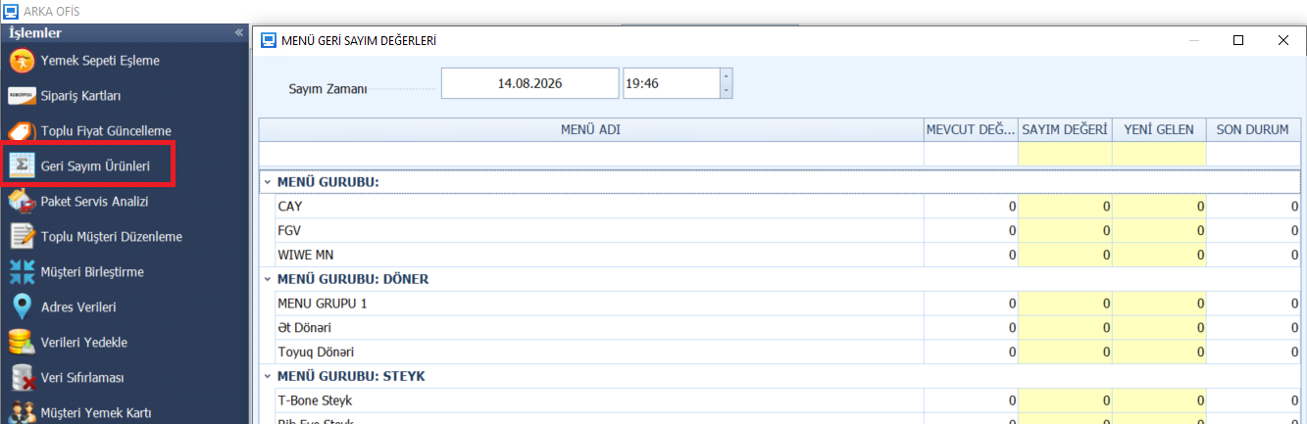
Paket Servis Analizi:
SET TRANSACTION ISOLATION LEVEL READ UNCOMMITTED;WITH lo as (SELECT CustomerKey,MAX(OrderDateTime) AS lastDate FROM OrderHeaders WHERE OrderType=5 GROUP BY CustomerKey)
SELECT c.AutoID, c.CustomerKey, c.CustomerName,c.AddressNotes,lo.LastDate AS LastOrderDate,isnull(phone.PhoneNumber,'') AS PhoneNumber,
COUNT(h.AutoID) AS OrderCount,isnull(SUM(h.AmountDue),0) AS OrderTotal
FROM CustomerFiles AS c
LEFT OUTER JOIN lo ON lo.CustomerKey = c.CustomerKey
LEFT OUTER JOIN OrderHeaders AS h ON h.CustomerKey=c.CustomerKey AND h.OrderType=5 AND h.LineDeleted=0
LEFT OUTER JOIN CustomerPhones AS phone ON phone.CustomerKey = c.CustomerKey
GROUP BY c.AutoID, c.CustomerKey, c.CustomerName,c.AddressNotes,lo.LastDate,phone.PhoneNumber
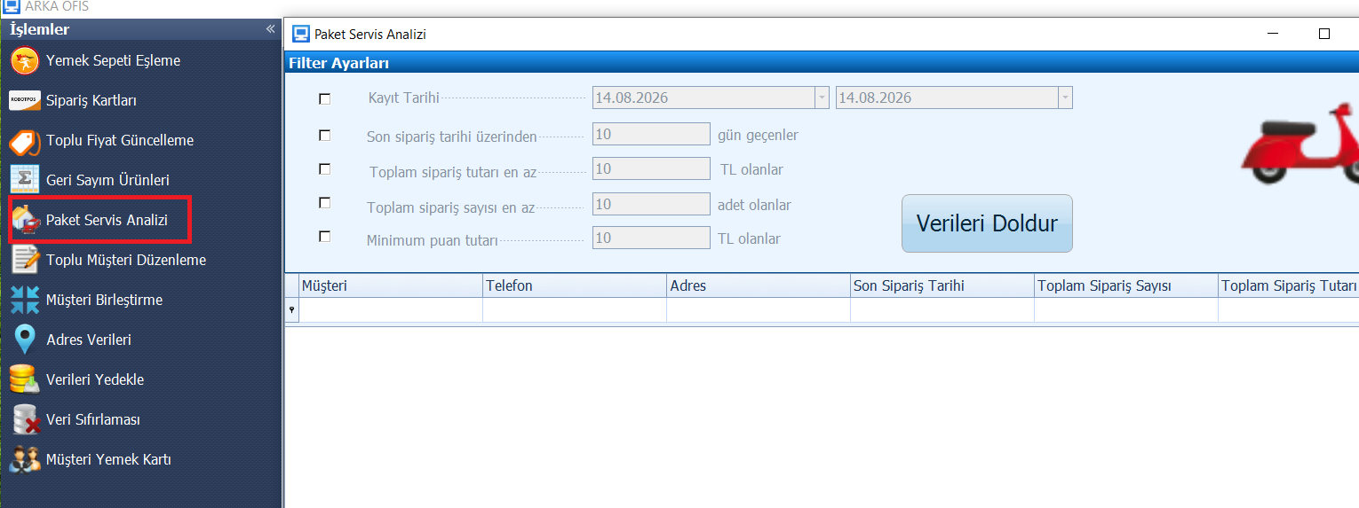
Toplu müşteri düzenleme:
SELECT CustomerFiles.WebUserName, CustomerFiles.WebPassword, CustomerFiles.AutoID, CustomerFiles.CustomerID, CustomerFiles.CustomerKey,CustomerFiles.CustomerGlobalKey, CustomerFiles.CustomerIsActive, CustomerFiles.CustomerName,CustomerFiles.CustomerFullName, CustomerFiles.CardNumber, CustomerFiles.CustomerNotes, CustomerFiles.OrderCount,
CustomerFiles.LastCallDate, CustomerFiles.CallingCount, CustomerFiles.AllowHouseAccount, CustomerFiles.IsFrequentDiner, CustomerFiles.CreditLimit, CustomerFiles.CreditSatusID, CustomerFiles.DiscountPercent,
CustomerFiles.SpecialBonusPercent, CustomerFiles.TotalDebt, CustomerFiles.TotalPayment, CustomerFiles.TotalRemainig, isnull(CustomerFiles.BonusStartupValue,0) as BonusStartupValue, isnull(CustomerFiles.TotalBonusUsed,0) as TotalBonusUsed, isnull(CustomerFiles.TotalBonusEarned,0) as TotalBonusEarned, isnull(CustomerFiles.TotalBonusRemaing,0) as TotalBonusRemaing, CustomerFiles.CityName,
CustomerFiles.District, CustomerFiles.Neighborhood, CustomerFiles.Avenue, CustomerFiles.Street, CustomerFiles.Buildings, CustomerFiles.Block, CustomerFiles.Apartment, CustomerFiles.ApartmentNo, CustomerFiles.FlatNo, CustomerFiles.IsDefault, CustomerFiles.TaxOfficeName,
CustomerFiles.TaxNumber, CustomerFiles.ZipCode, CustomerFiles.AddressNotes, CustomerFiles.AreaCode, CustomerFiles.CustomerSpecialNotes, CustomerFiles.BirthDay, CustomerFiles.MaritialStatus, CustomerFiles.Age, CustomerFiles.EmailAddress,
CustomerFiles.Sexuality, CustomerFiles.FacebookAccount, CustomerFiles.TwitterAccount, CustomerFiles.WebSite, CustomerFiles.PhotoPath, CustomerFiles.ProximityCardID, CustomerFiles.EditKey, CustomerFiles.SyncKey, CustomerFiles.BranchID,
CustomerFiles.LockData, CustomerFiles.LockStationID, CustomerFiles.AddUserID, CustomerFiles.AddDateTime, CustomerFiles.EditUserID, CustomerFiles.EditDateTime, isnull(CustomerFiles.OpenValue,0) AS OpenValue, isnull(CustomerFiles.AparmentFlatNo,'') AS AparmentFlatNo
,'' AS AddressText,isnull(br.BranchName,'') as BranchName,
(isnull(CustomerFiles.CreditLimit,0)-isnull(CustomerFiles.TotalDebt,0)) as RemainCreditLimit ,isnull(CustomerFiles.IsEmployee,0) as IsEmployee, isnull(CustomerFiles.DetailData,'') AS DetailData
FROM CustomerFiles
LEFT OUTER JOIN efr_Branchs AS br ON CustomerFiles.BranchID = br.BranchID
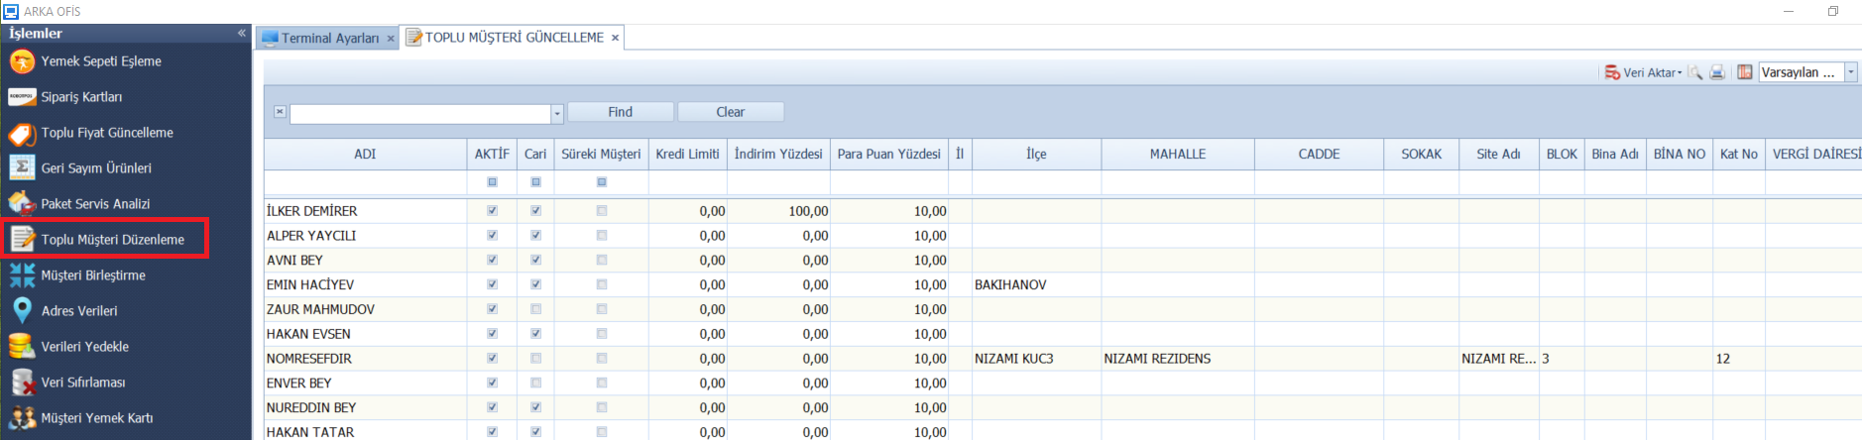
Müşteri Birleştirme:
SET TRANSACTION ISOLATION LEVEL READ UNCOMMITTED;SELECT CustomerFiles.AutoID, CustomerFiles.CustomerID, CustomerFiles.CustomerKey,CustomerFiles.CustomerName,CustomerFiles.CustomerFullName,
CustomerFiles.BranchID,isnull(br.BranchName,'') as BranchName, isnull(CustomerFiles.IsEmployee,0) as IsEmployee,isnull(CustomerFiles.DiscountPercent,0) AS DiscountPercent
,ISNULL(p.PhoneNumber,'') AS PhoneNumber,ISNULL(p2.PhoneNumber,'') AS PhoneNumber2
FROM CustomerFiles WITH(NOLOCK)
LEFT OUTER JOIN efr_Branchs AS br ON CustomerFiles.BranchID = br.BranchID
LEFT OUTER JOIN (
SELECT isnull(MIN(p.PhoneNumberID),0) AS phoneID,isnull(MIN(r.PhoneNumberID),0) AS phoneID2,p.CustomerKey FROM CustomerPhones AS p
LEFT OUTER JOIN CustomerPhones AS r ON p.CustomerKey=r.CustomerKey
AND r.PhoneNumberID>p.PhoneNumberID
GROUP BY p.CustomerKey
) AS r ON CustomerFiles.CustomerKey=r.CustomerKey
LEFT OUTER JOIN CustomerPhones AS p ON p.PhoneNumberID=r.phoneID
LEFT OUTER JOIN CustomerPhones AS p2 ON p2.PhoneNumberID=r.phoneID2
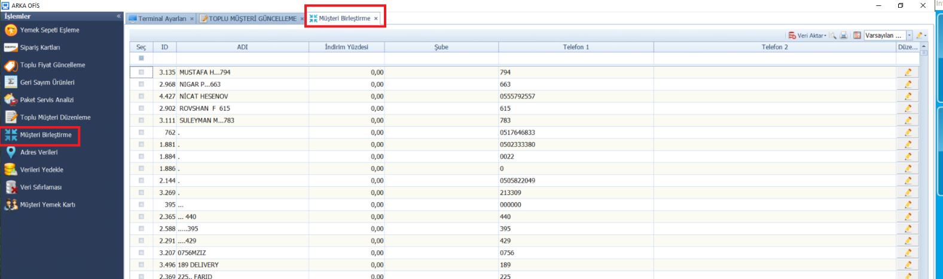
Adres Verileri:
SELECT [AutoID] , [IL_ID] , [ILCE_ID] , [MAHALLE_ID] , [TUR_ID] , [AD] , isnull([BranchID],0) as BranchID , isnull([MinimumPrice],0.0) as MinimumPrice , isnull([DeliveryPrice],0.0) as DeliveryPrice,[Sokak] FROM [tblCaddeSokak] where [MAHALLE_ID]=1
